**Technology Learning Studio Journal**

**Fall 2018**

**Sanchit Singhal**

**August 29, 2018**

Today was our first class for Technology Learning Studio. It’s a course taught by Dr.James Howison at the University of Texas’ iSchool. I took this course because of several reasons (arbitrary order):

* I think it is important to learn about “how to learn”. Especially for me since I want to work in the information technology sector after graduation. Given the rapid rate of change in both software and information architecture, I foresee this skill being vital for my career and staying relevant in the job market.
* There are specific technologies that I encountered during my internship over the summer working in the Information Systems department of a petroleum firm in Houston, EOG Resources. I want to learn some of the software but, understandably, UT does not have designated courses for all of these. Since I plan to work through some of these new tools anyways, I figured that taking this class would enable me to reserve some time out of my schedule for this.
* I really like the professor's teaching style. I have previously audited one of Dr.Howison class and I enjoyed the structured yet fun vibe. He keeps the class engaging and promotes discussion - which I appreciate.

During class, I learned that we will be keeping a learning journal during the semester in order to track our thoughts (I assume we will be referring to and using this for class discussions as well). This post is obviously the first entry in the journal.

It was great to meet my fellow peers in the course and bounce ideas off of them about different modules that could be interesting. We conducted a little card activity that got the ball rolling for some of these talks. Although, I am still unsure what my learning modules might be (a little concerned about the physical one - maybe building a computer?), I have finalized my first learning module.

**Learning Module 1: Docker Containers (operating system level virtualization)**

I want to learn and get proficient at Docker. I have started to outline some of my goals,

materials, and activities for the first module:

Goals

* Container fundamentals
* Container registries
* Container orchestration
* Core Docker technologies
* Docker swarm clustering (stretch)
* Deploy a practice project that utilizes docker containers (one for web app and one for database back-end)

Materials

* Pluralsight course : "Managing containers with docker" ([https://app.pluralsight.com/paths/skills/managing-containers-with-docker (Links to an external site.)Links to an external site.](https://app.pluralsight.com/paths/skills/managing-containers-with-docker))
  + follow beginner and intermediate tracks, start advanced topics (time permitting)
* Youtube
* Docker website

Activities

* do practice exercises that are provided in the Pluralsight course ([https://app.pluralsight.com/paths/skills/managing-containers-with-docker (Links to an external site.)Links to an external site.](https://app.pluralsight.com/paths/skills/managing-containers-with-docker) )
* implement a final working project that uses docker

Offline Community

* attend one meetup event in Austin about Docker ([https://www.meetup.com/Docker-Austin/ (Links to an external site.)Links to an external site.](https://www.meetup.com/Docker-Austin/) )

I also read through some of the other posts on the discussion board and connected with Josh. He is going to be attending some Linux meetups so hopefully I’ll be able to tag along with him to those during the semester - I’m excited!

**September 5, 2018**

Today is the second class of the course. I have not had too much time so far to work further on the first learning module as the start of a new school year is always a busy time - I am still figuring out my courses, starting a new on-campus job, preparing for the career fairs, and all kinds of other things are going on. As anticipated, it is definitely nice to have some time allocated to working on the module (I feel like I would just put it off if I just attempted to do this in my own time). Before I get started on the Pluralsight course (which I intend to make my primary mode of learning material, I wanted to identify a technology learning blog on this topic. Going to the official webpage for Docker, I was happy to note that they had a forum (<https://forums.docker.com/>) . Although this is a little different to the style of blog I am attempting, it is nice to see an online community interacting with each other to learn, debug, and share ideas. I also found another blog by Romin Irani, <https://rominirani.com/docker-tutorial-series-a7e6ff90a023> that is a more personal experience.

**September 8, 2018**

It’s finally the weekend and I’ve had some time to get started on the Pluralsight course. The structure of the MOOC is well organized. It is broken out into 19 hours of “Beginner”, 16 hours of “Intermediate”, and 5 hours of “Advanced”. My goal is to complete the first module - a week from today. The first video, “Docker and Containers: The Big Picture”, was a very informative because it provided an overview of containers and docker. It really dives into how to prepare for industry-use of container and why it’s useful for projects in the real world. Docker Hub and Container Orchestration are also mentioned at a high-level. Although the video was helpful to gage the scope of the course and what I can expect in the future, it did not begin the technical details of the technology yet. The next video should start getting into the actual implementation of the tool. I want to follow along with the video on my laptop so I learn by doing - rather than just watching. I feel like that way I will remember what I am learning better.

**September 12, 2018**

Today I finished the first module of the Pluralsight course. I was following on with the videos on my laptop so that I could actually do the steps being mentioned. I started with learning how to install Docker on two of my preferred platforms - Windows and Linux:

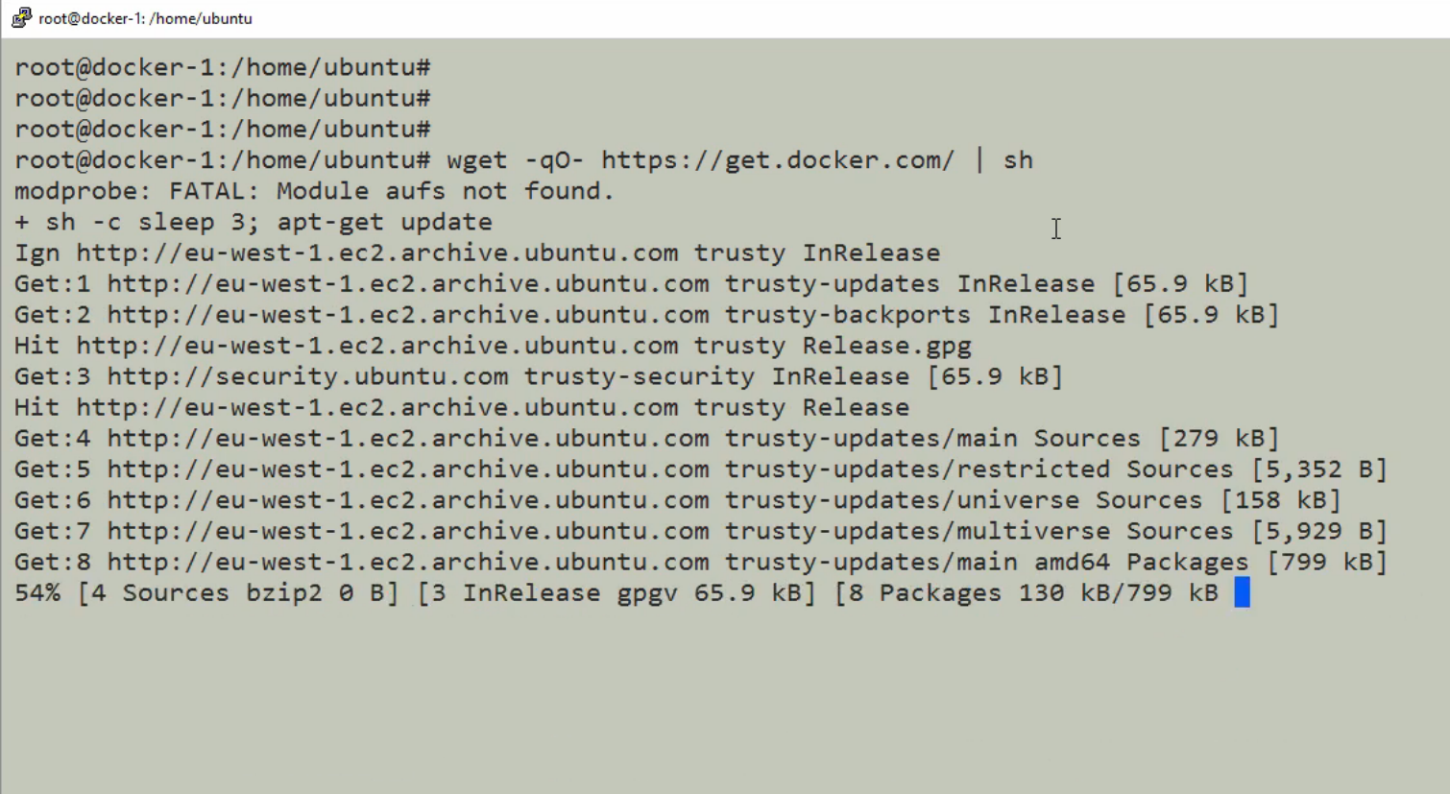

The next couple of steps were probably most useful - to see some fundamental concepts of containers and images. I also learned how to perform some common management tasks:

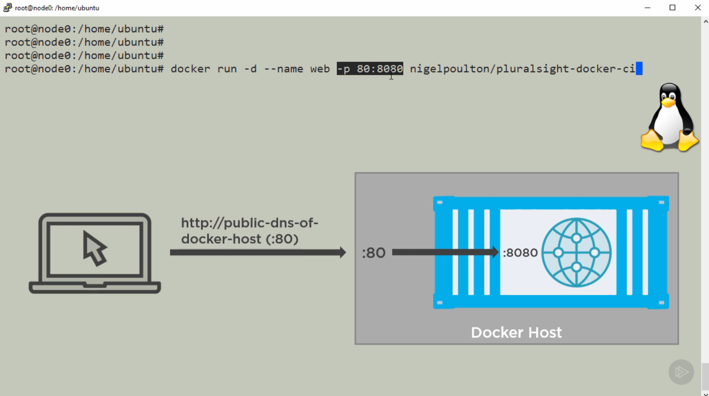

I am currently playing with Docker 1.12 (which is apparently a version with some major updates) - I got see Swarm mode, services, scaling, rolling updates, stacks, and distributed application bundles:

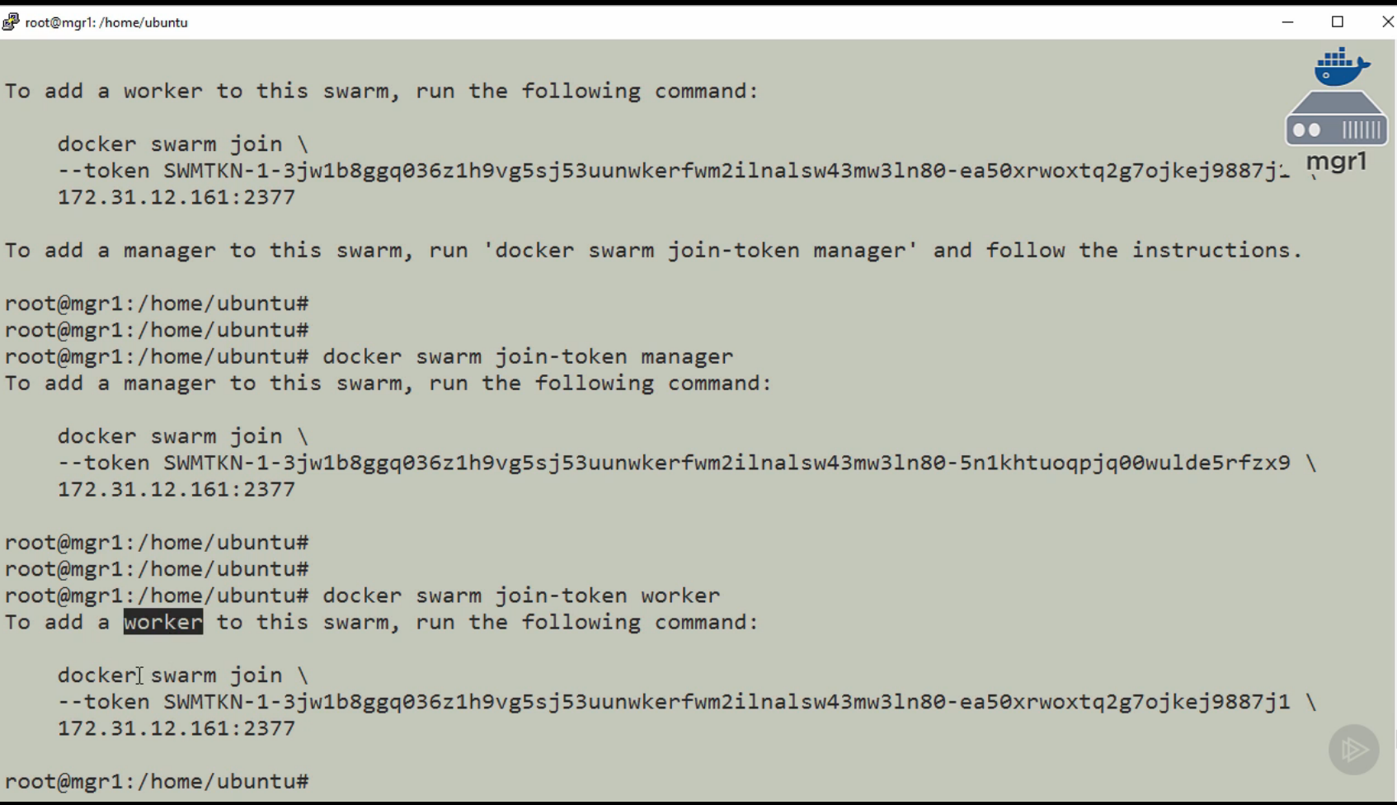

I can see why most of these tasks would be useful during app development but I am still not sure about a few of the functionality and how I would use it in the real world. As I work through these videos I realize that although I am learning some of the basic commands and its useful for an instructor to talk through the ideas, I am having a hard time figuring out why and in what situations this would come in handy - I guess this is where experience comes into play and the more I work with these tools, the more intuitive it will feel.

**September 19****, 2018**

During class today, we discussed the concepts of Fixed vs Growth mindsets. To be honest, I have not thought too much about such topics - although perhaps subconsciously I do have some opinions that are immersed in these areas. The readings and then the class contributions really helped me to frame my thoughts in a more structured way. I believe I have always had a growth mindset in sport - the more I play/practice the more fit and skillful I believe one can get. I tend to have a more fixed mindset about fine arts. I have always been weak at sketching/drawing and perhaps this is why I have not tried harder to improve upon these skills. It’s maybe more important to have a growth mindset about having a certain mindset and it’s not too late to alter the way I think. I can definitely try to be more optimistic in certain areas of my life. It was also interesting to talk about how we interact with other people’s mindset. It is often difficult to have growth conversations and I now realize the difference might be the approach we take towards that.

Putting these concepts in the context of my first learning project, I am definitely approach Docker with a growth mindset. Being a software engineer, I am used to code that doesn’t work right or even fails to run - and it’s quite normal to debug, find the issue, and fix it one step at a time until it functions the way I want it to. I believe this helps me understand that the more I work at something, the more I will understand it and can manipulate the tool to be beneficial for the use case I am working on. Now that I understand the overall concept of Docker, I have a solid mental map of the technology and feel confident I can build upon my knowledge when and where required.

**September 26****, 2018**

During today’s class discussion, Dr.Howison had us think about professionals that use the module we are learning by considering how they got where they are today, how they learn, and what their career path in the future is. This exercise was easy for me - I have specifically selected to learning Docker because I met people at my internship who use it. Most of my colleagues learned Docker, probably similar to me, by watching some tutorials and then by simply playing around with it. Discussing with each other and coming up with new strategies that benefit the development we do. Most of the developers I know that use Docker initially started to do so in order to help themselves to do their job more efficiently. It was a pain deploying various parts of apps to different servers and by containerizing them it helps them build an environment much more modularly. The future career path for most is to keep getting more technically apt at data engineering. This is a job role I can see myself working as after my degree and I suppose that is what attracted me towards learning Docker in the first place. This idea of observing this community of practice was interesting because I got to learn all the mundane fringe tasks that go into learning docker. It is obviously useful to be good at working with servers and requires some basic knowledge about bash, networking, and how deployments function at organizations.

I also started thinking about my second learning module that I want to do. It is advised that we do the physical project next. I had a hard time trying to finalize this project - embarrassingly I could not think about anything I wanted to learn that was physical in nature - but mostly because I wanted to learn something that would be useful for me at my job in the future. After bouncing some ideas of other people - I had a very engaging conversation with Halie. She is considering making a robot and this seemed interesting. She is building a robot and I thought it’d be cool for me to a build a car for it ( I want to begin simple). After doing some research, I realize that there are two main board that people use: Adruino and Rasberry Pi. I explored the room we use for class and even found some useful items at the back (there is somebody definitely tinkering with this type of stuff as well - probably whoever built the 3D printer). I have gone ahead and ordered a kit from Amazon so that it will be here for next class: <https://www.amazon.com/gp/product/B076M7JM8R/ref=oh_aui_detailpage_o00_s00?ie=UTF8&psc=1>

Next week I also plan on attending a meetup in downtown Austin that is focused around clouding computing. Although not specifically a docker meetup ( the meetup group that I had originally identified seems to be fairly inactive with no event in the near future), I believe it will be relevant for me as most Docker containers live in the cloud. It will be a great experience to try and see this type of community of practice.

**October 2****, 2018**

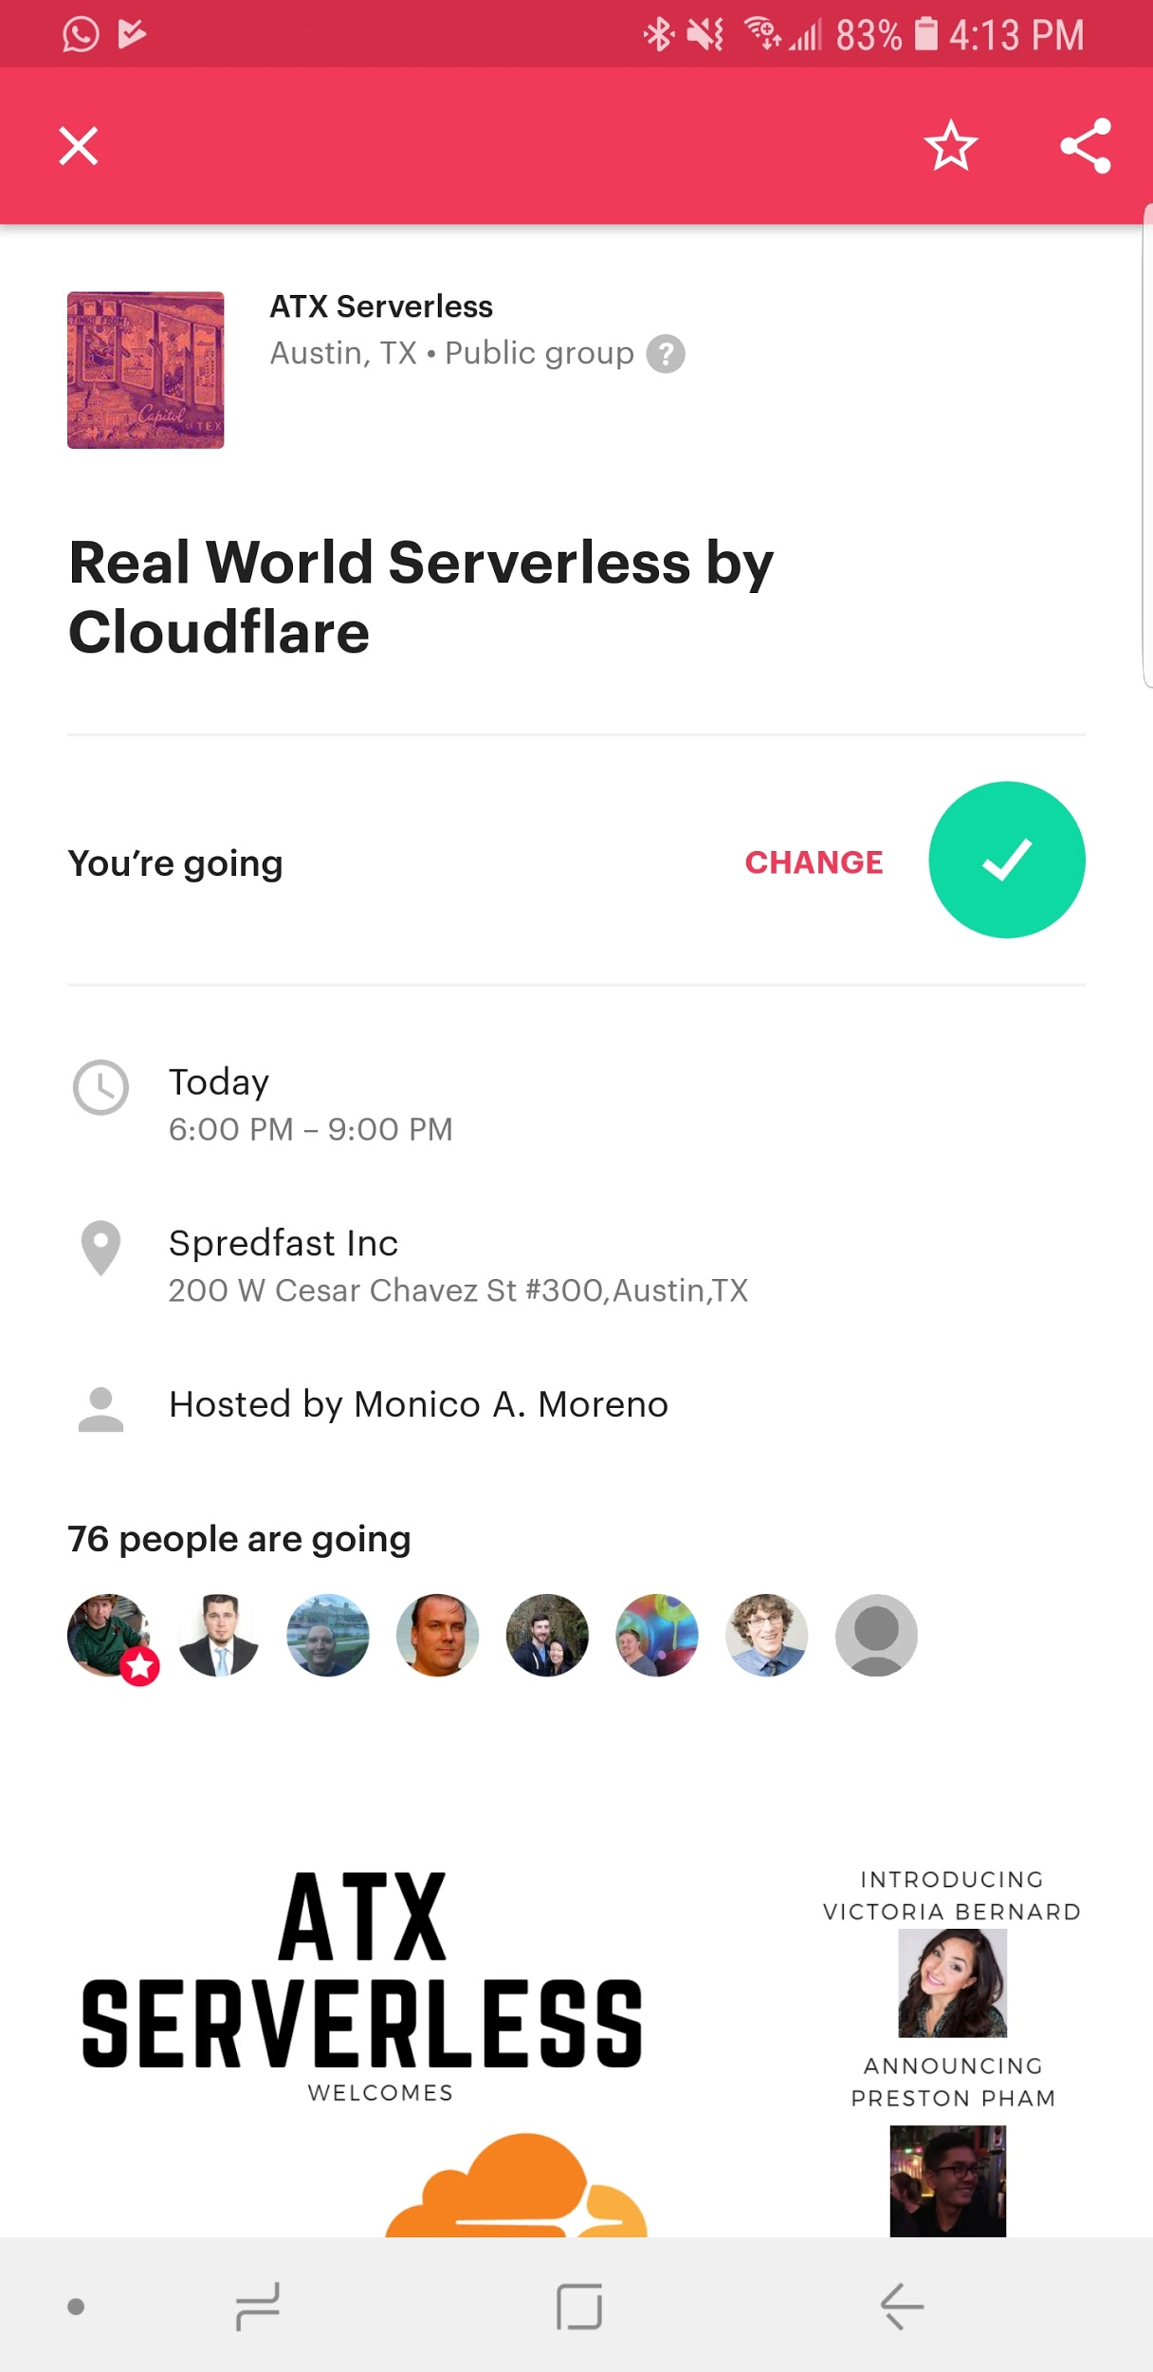

Today I went to my first meetup (I have always wanted to go since the start of my degree but somehow never got around to it). The event was hosted by a group called “ATX Serverless” and mainly consisted of presentations from employees of CloudFare, a networking platform company. It was a collaborative event in which the space was provided by Spredfast, another company downtown, and the event’s logistic (food and prizes) were sponsored by other companies.

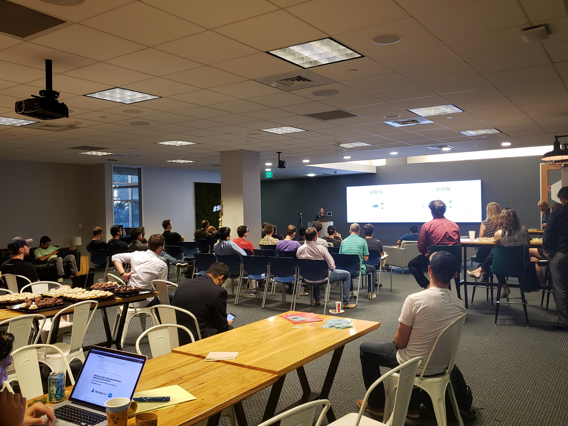

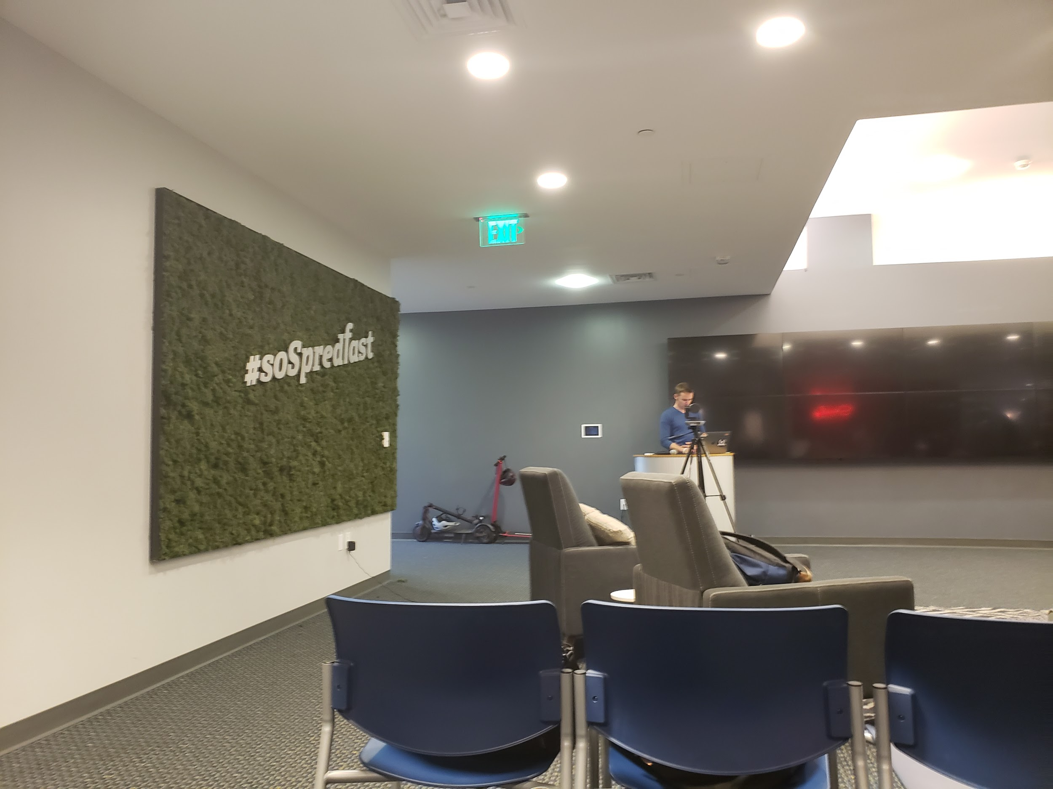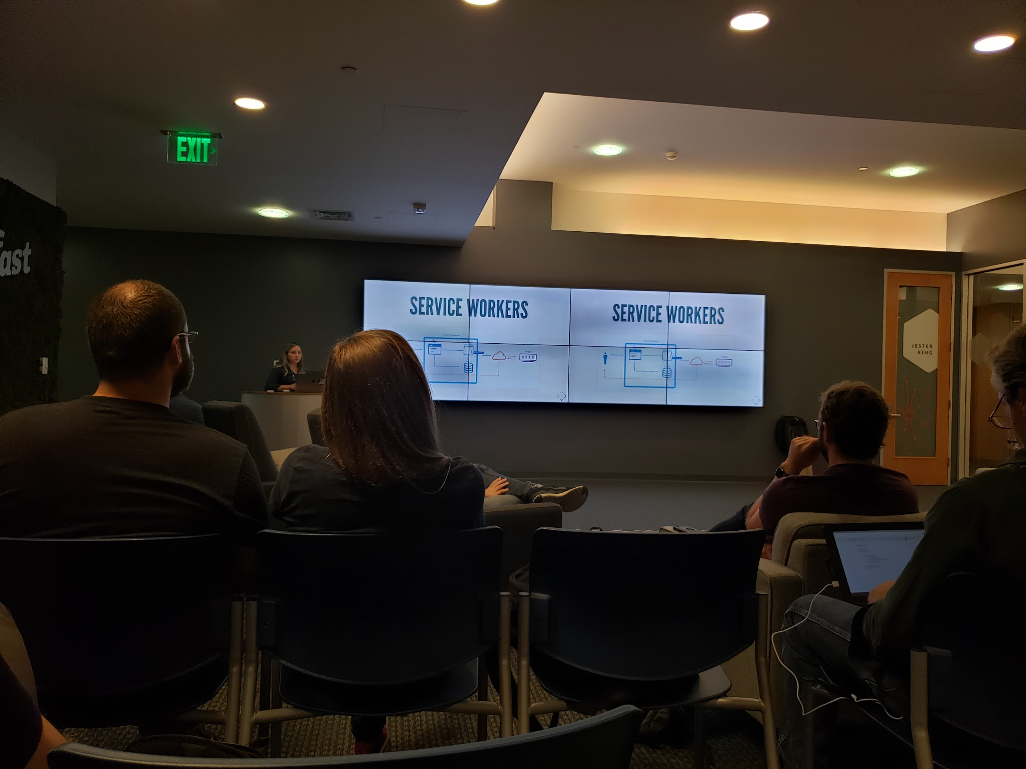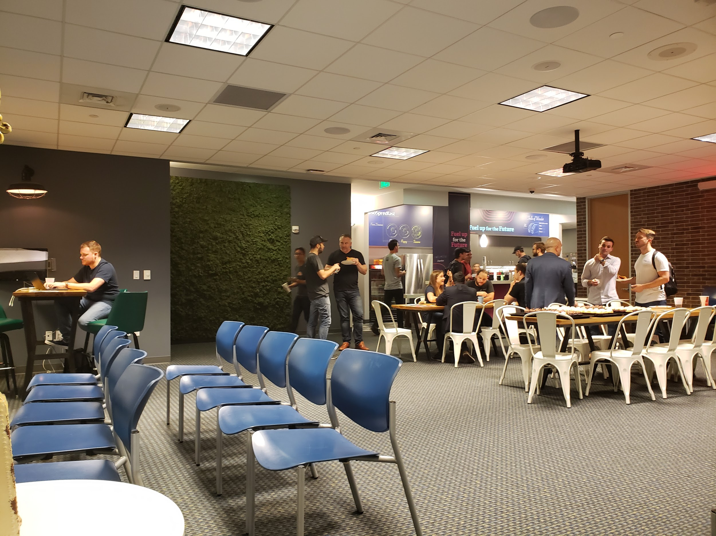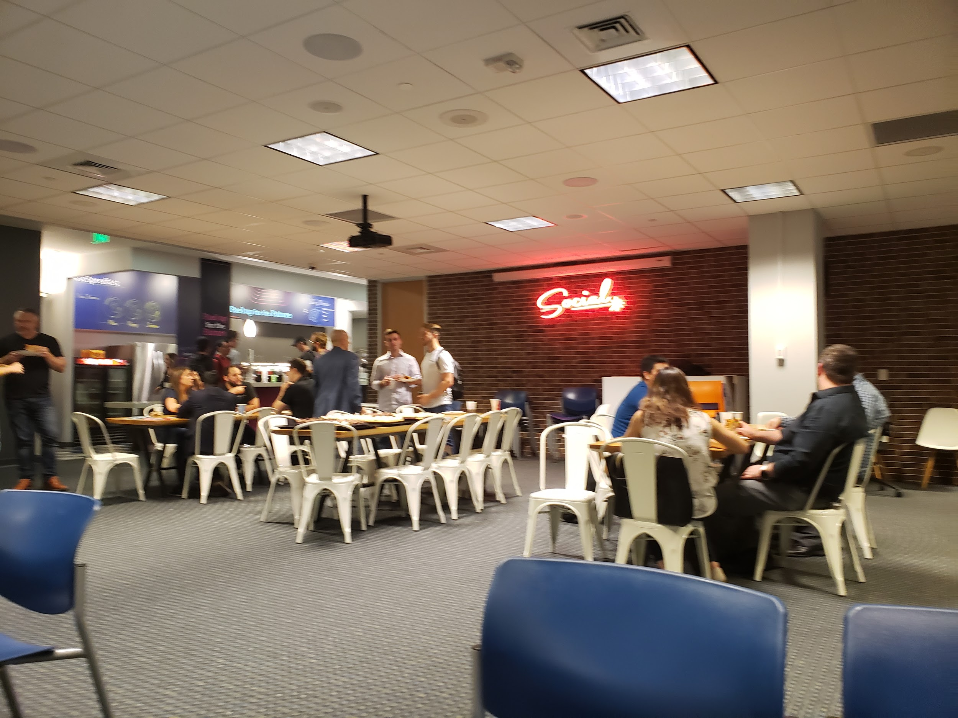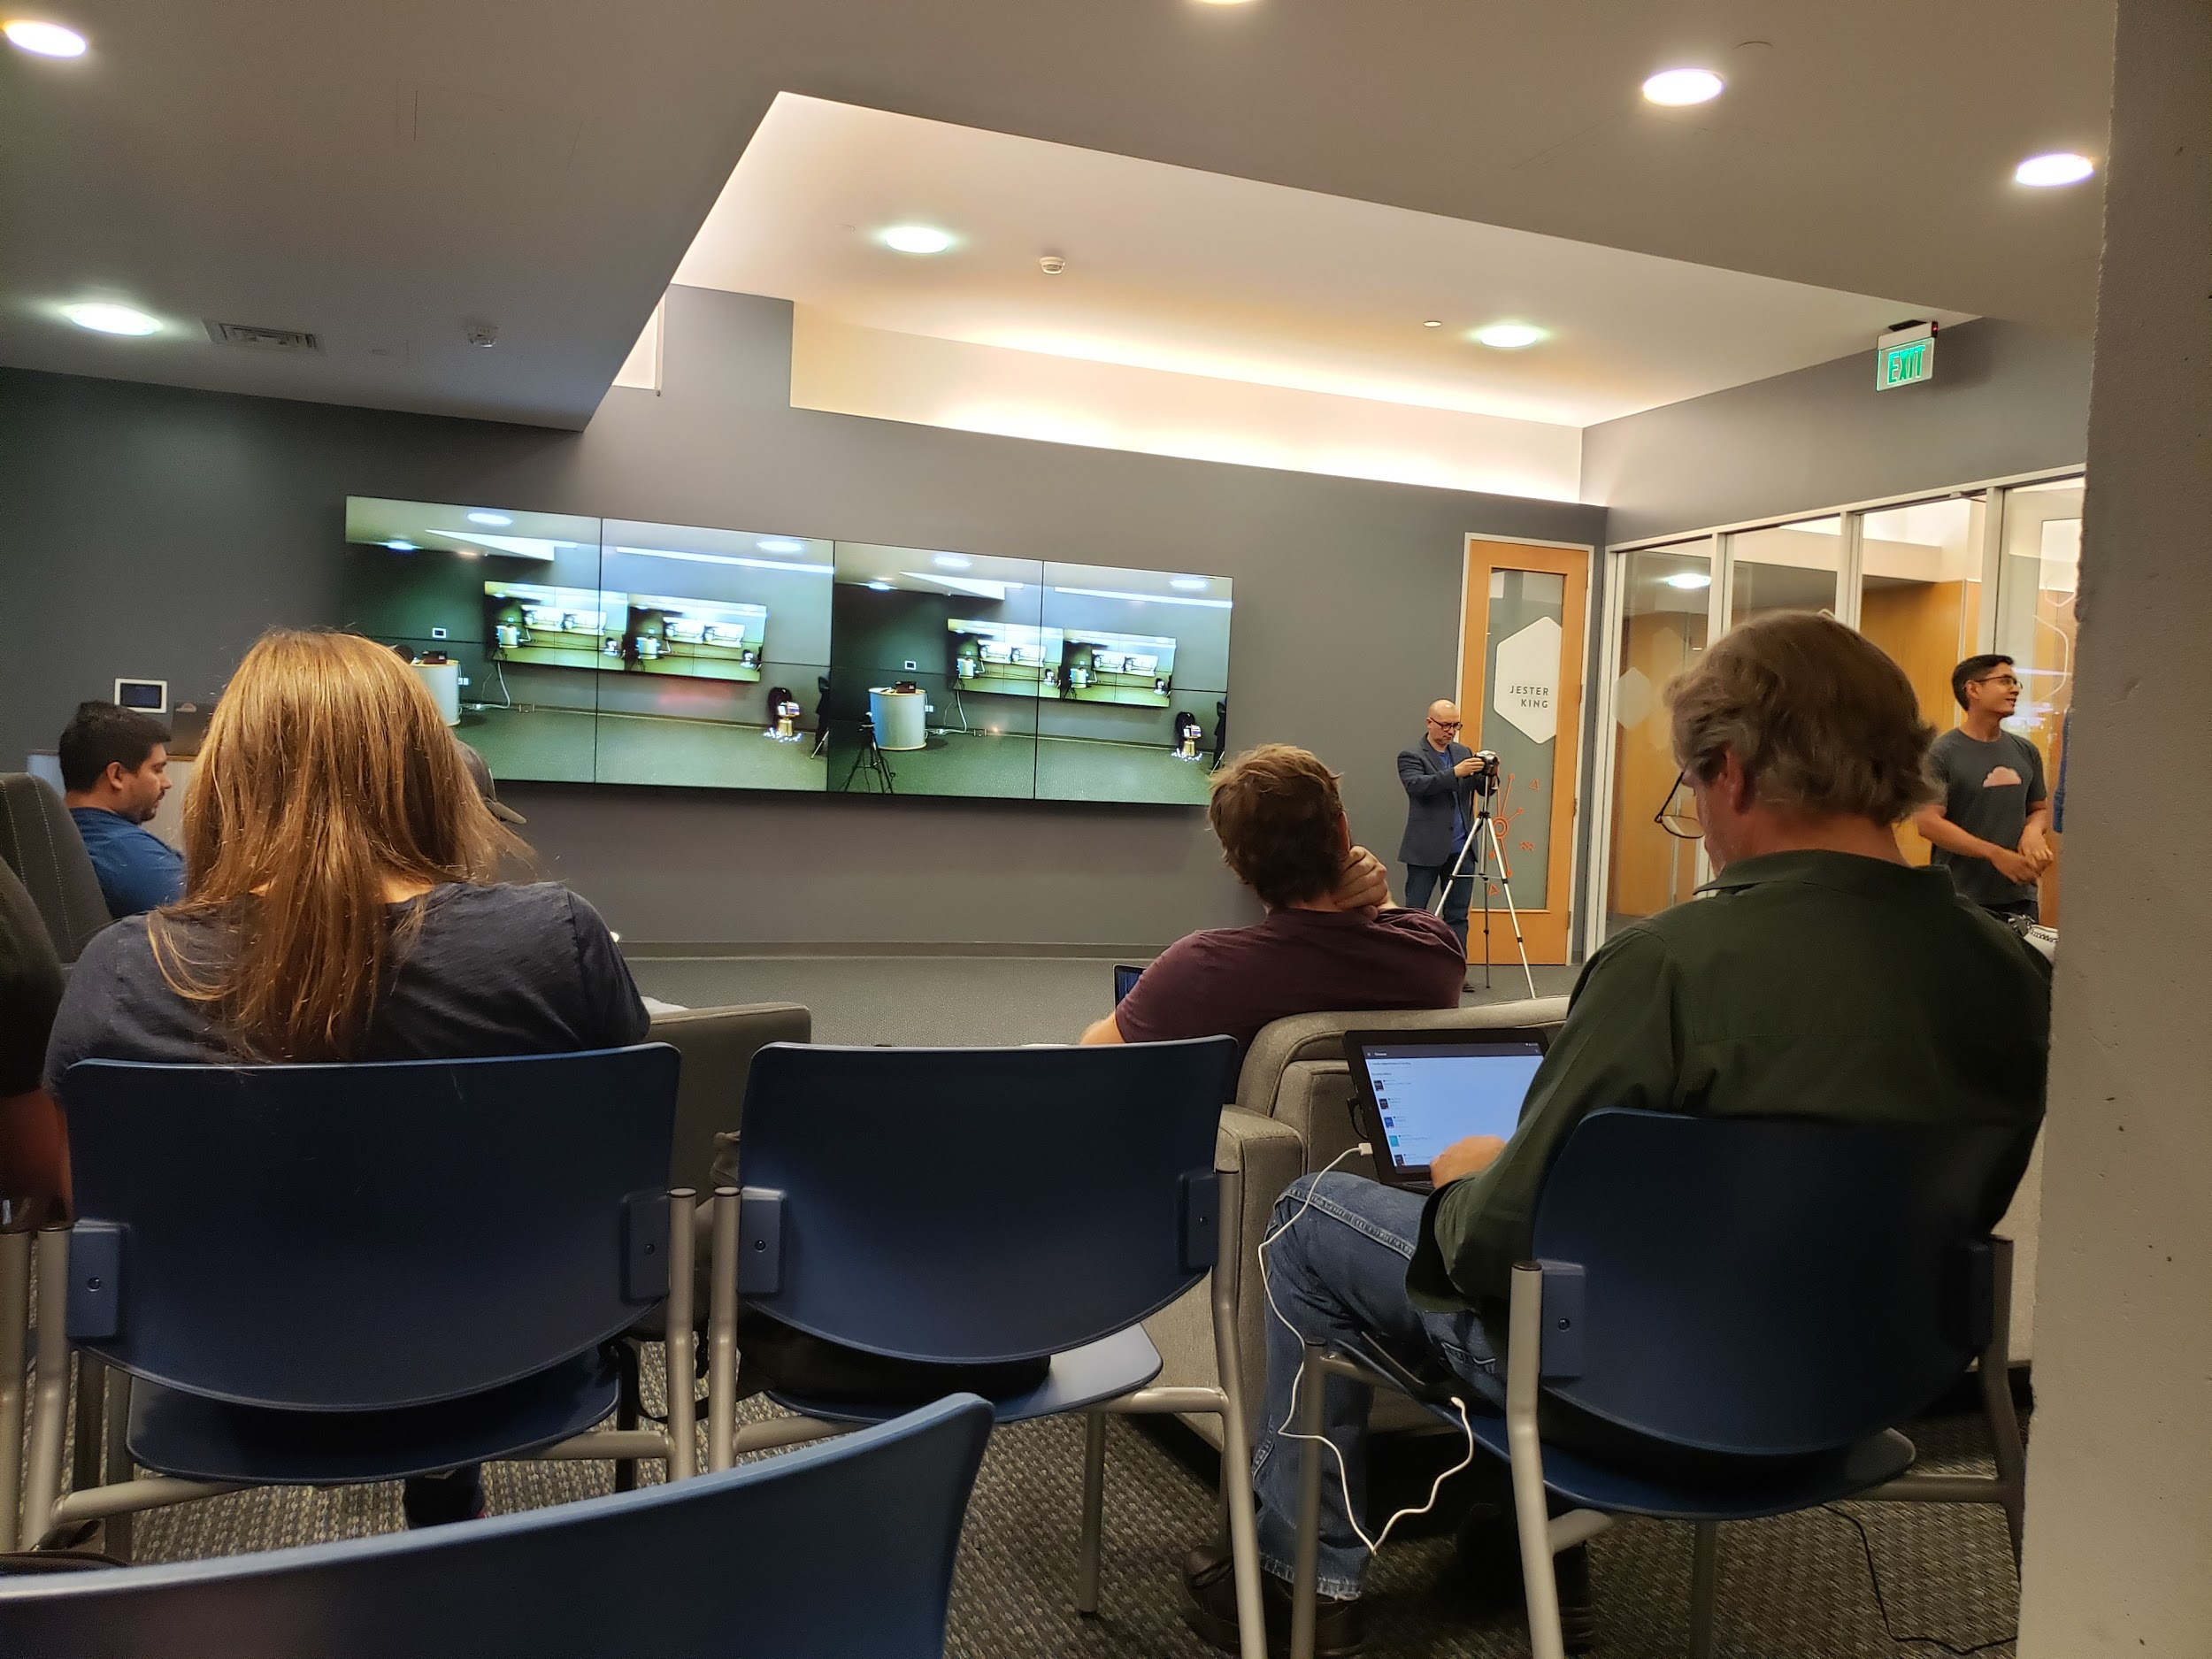

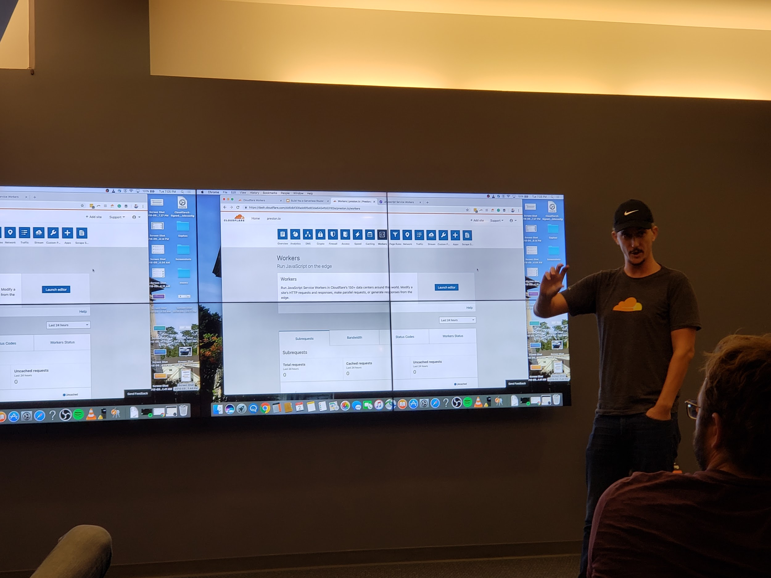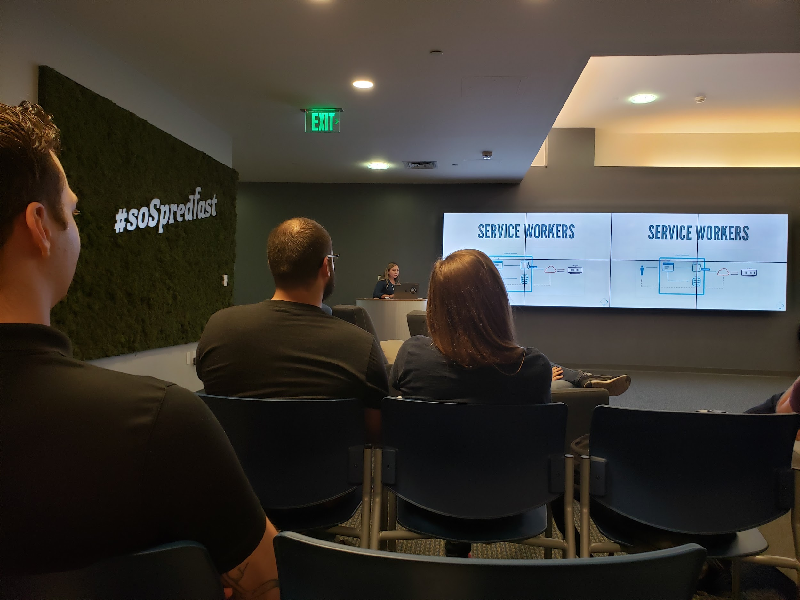

I got to learn a lot about emerging way developers are playing around with cloud technologies and it was great to network with a few of them. To my surprise, a lot of recruiters were also at the event. Although most of the content seemed to be about presenting Cloudfare’s product, the mingling session before and afterwards gave me an opportunity to talk to other developers that are actually using Docker (one guy was even wearing a Docker t-shirt). All of them seemed convinced that containers are definitely going to be big in the future which reassures me my conviction about Docker. These were experienced developers who were sold on the benefit of the technology so there definitely must be practical usefulness which I have not quite realized. Overall, it was an awesome experience and I have built some connections which I intend on staying in touch with even after this event.

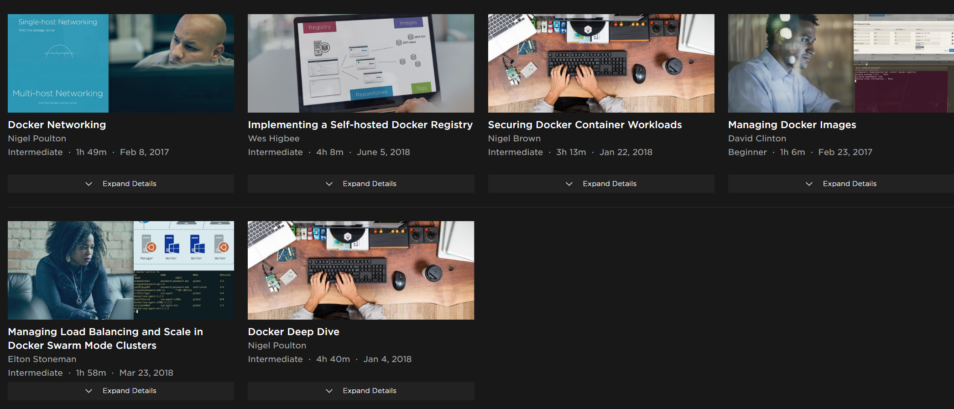

Currently, I am still working through the “Intermediate” module of the pluralsight course. I am a little disappointed at my progress. The biggest challenge I faced was time - even after watching most of the course at 1.5x speed, it was hard to allocate more time to watch the videos. I finished the 19 hour ‘beginner’ module but I think by implementing a project, I will get more hands on experience and by learn things as and when I need them will help me grow. I was able to gain valuable learnings about the overall concept and have a much better grasp of the tool ( I knew almost none of it before this module). I want to hopefully combine my first and second module to complete a final project in my third module which will allow me to construct a project using Docker. I will also of course continue learning Containers and Container Management tools outside of class as I am really starting to see the benefit of it. It is only after you start studying something is when you realize how much there is still left to learn. And with the constant evolution of the technology, I will attempt to stay up to speed in the space. The pluralsight course was helpful in giving me a jumpstart on Docker but I understand the importance of continual improvement.

**October 3, 2018**

Today is the start of the second learning module.There are several things I learned from my first learning module that I want to incorporate in my second for a better, more efficient experience. As mentioned in one of my earlier posts, time management was difficult for me. My goals were not concise enough, and I was not following a tight timeline which led to spending too much time on only a small section. It’s difficult in general when you are trying to learn a new tool in 4-5 weeks and therefore I think having a general outline will help me structure my learning better. Also, I want to start small and make sure I finish that before jumping onto a more complex project. In my second module, I will being doing the ‘physical’ one :

**Learning Module 2: Building a Robotic Buggy**

Goals:

* Build a functioning robot
* Learn how to program it by implementing/feeding code to the board
* Stretch goal - build custom rules for the robot
* Stretch goal - customize buggy by adding my own sensors

Materials: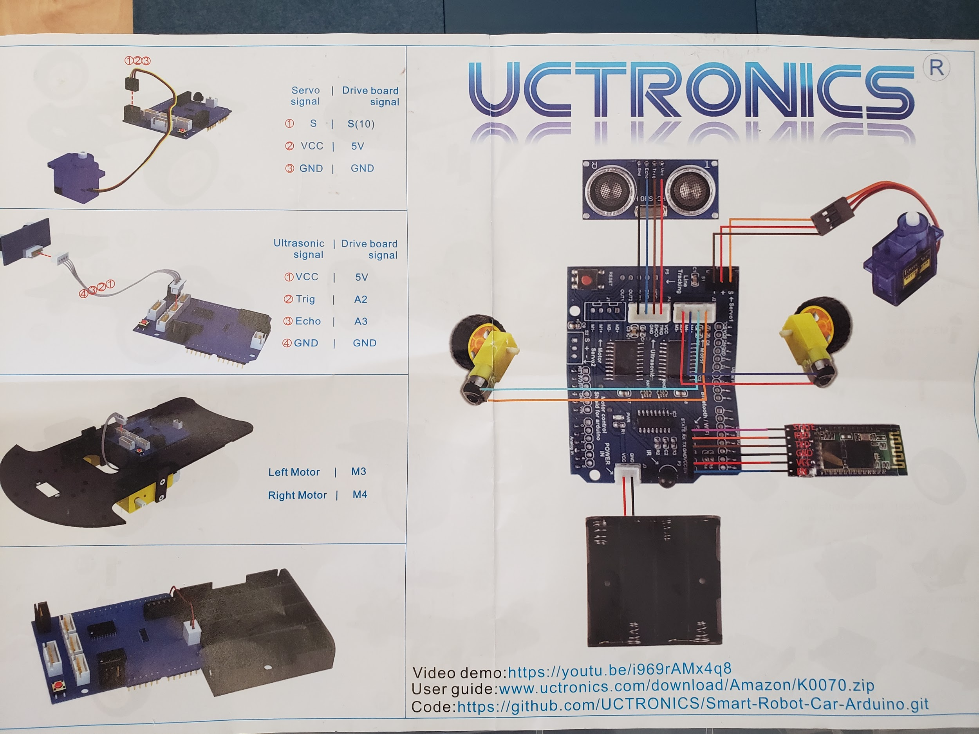

I am following a starter kit by Uctronics. This is nice because it is a self-contained educational toy which gives me access to not only the parts needed, but also video demos, user guides, and some code to run.

Activities:

Initially I will simply follow the starter kit and get up to speed with setting up the hardware, integrating software into and maybe attempt a harder, more complex problem upon completion of this kit: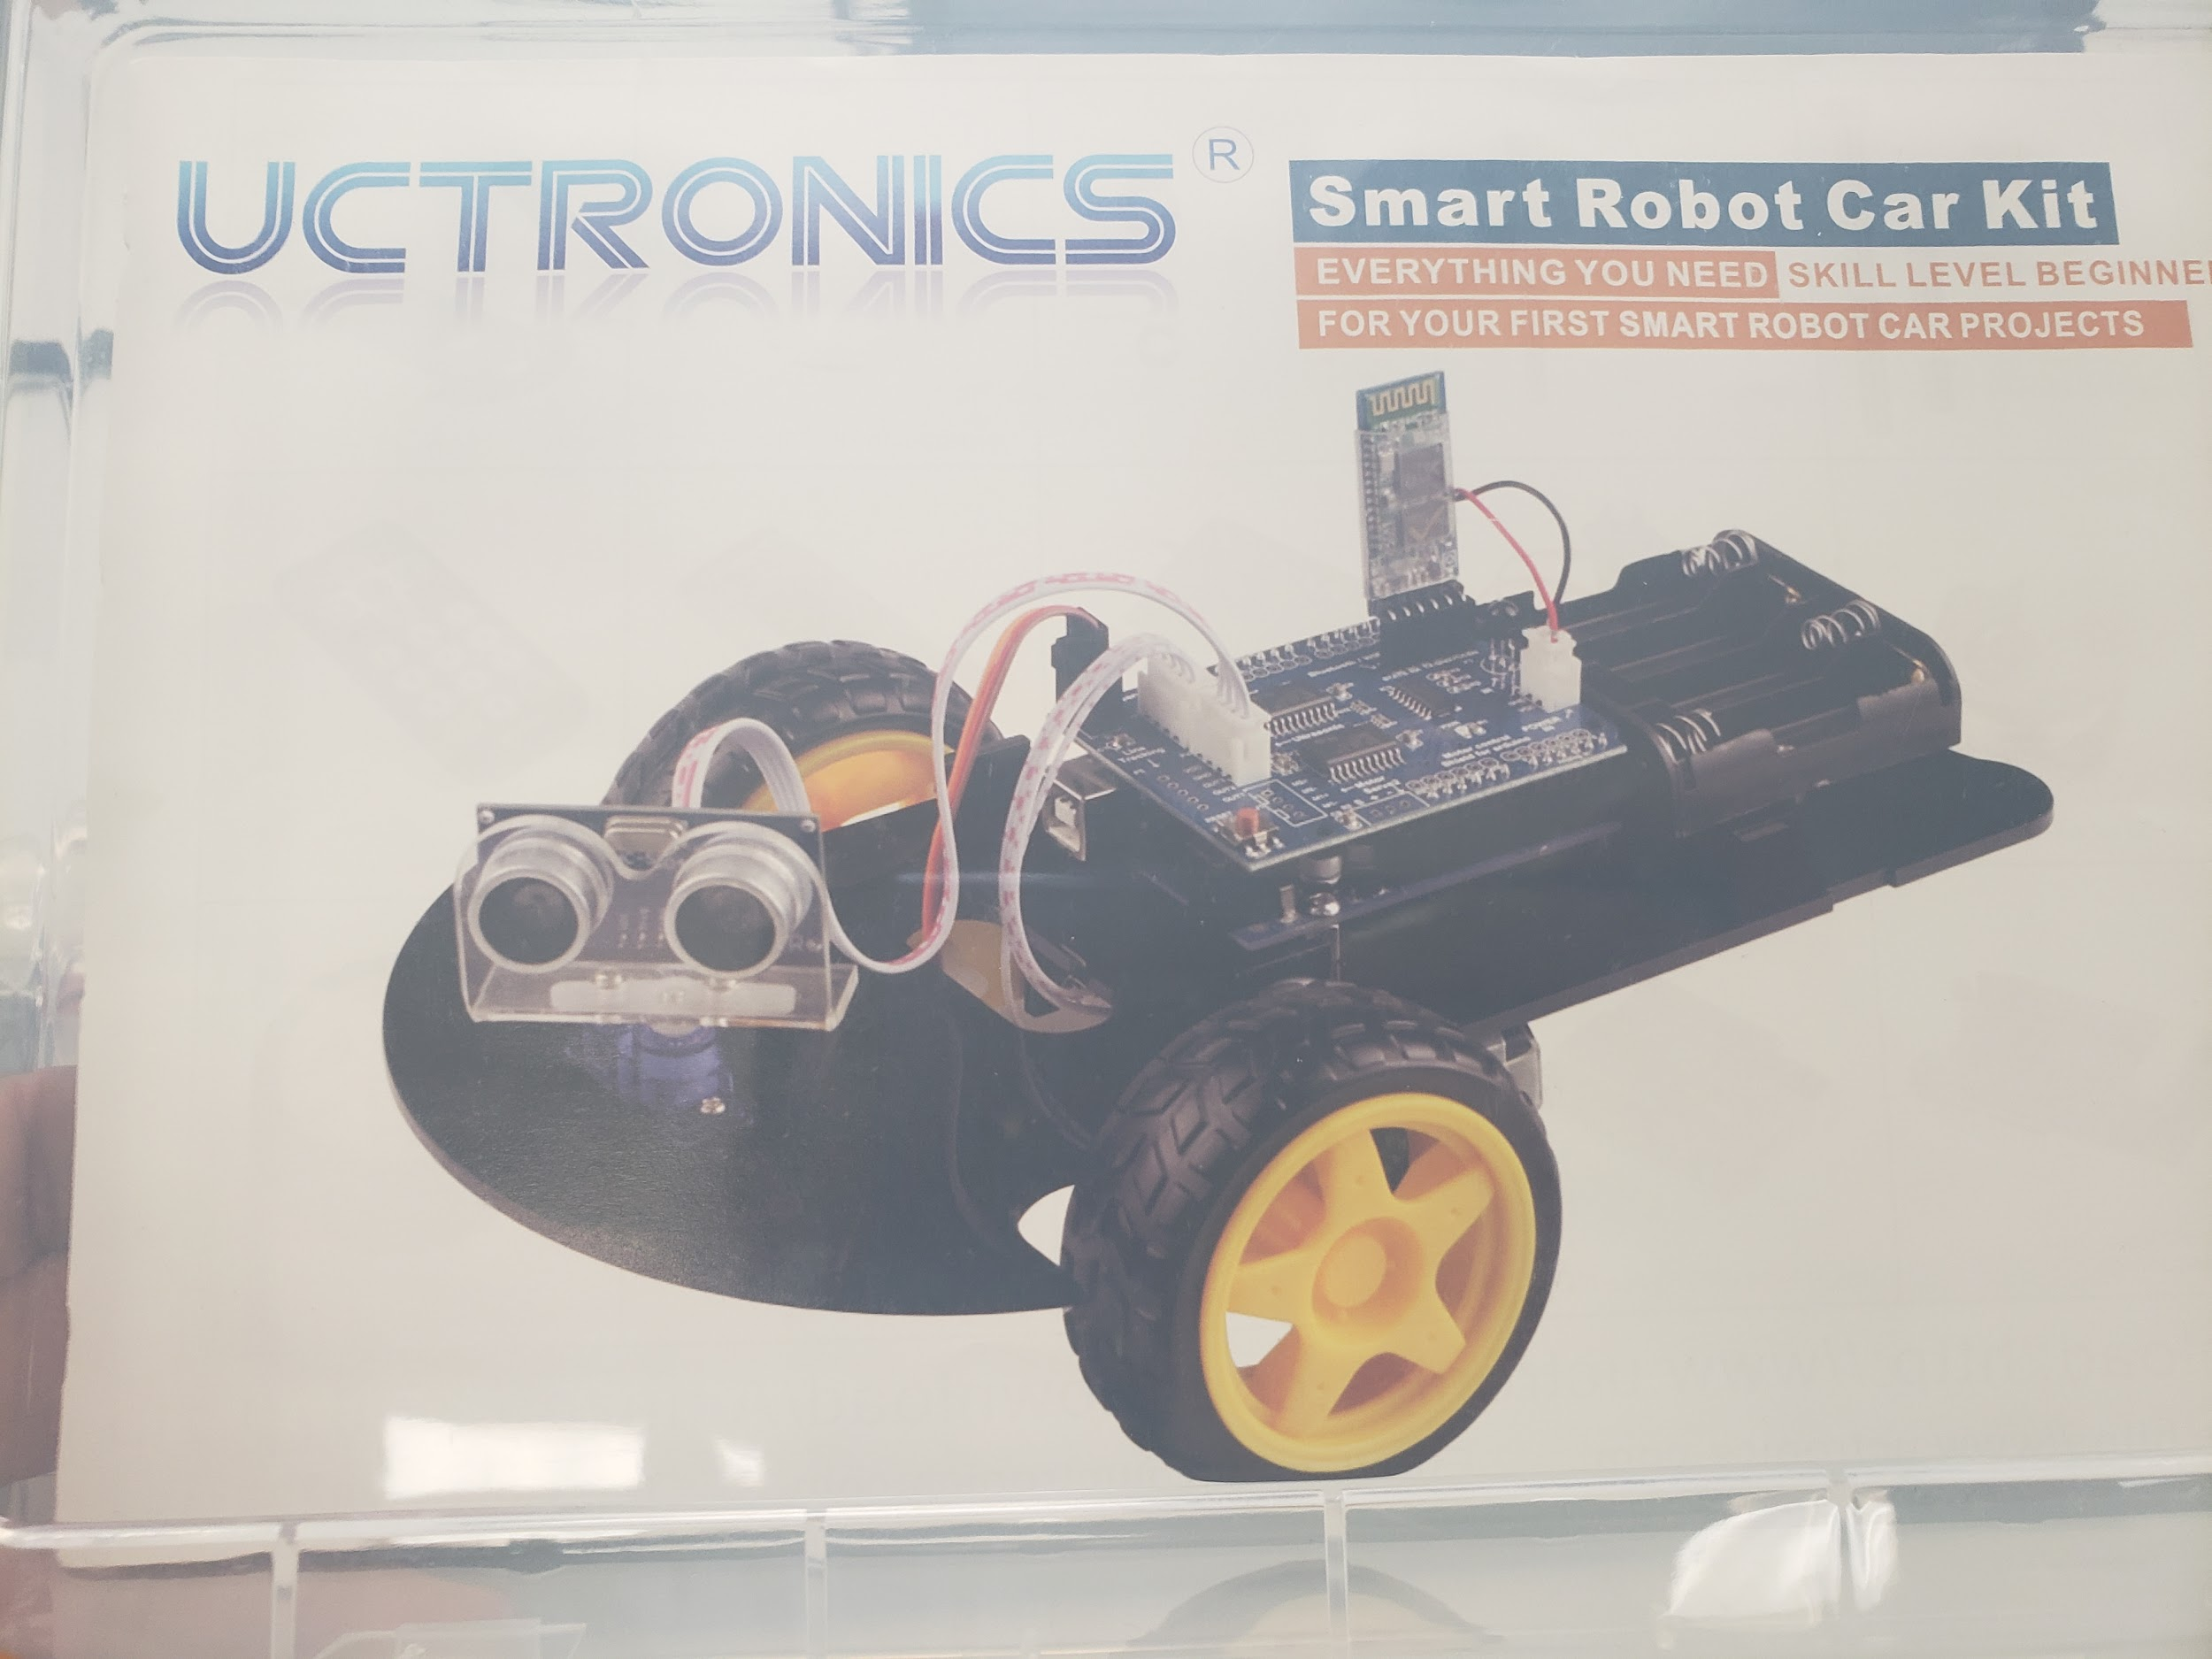

Offline Community:

Pedro, another student in his class, spoke to me about a meetup for Circuit Design which seems relevant for my offline community. I might even choose to write my Community of Practice paper on it if it goes well. These are the details:

Organizer: "DIY Music Makers"

Title: "Chill at Spiderhouse, bring a project for show & tell or just hang out".

Wednesday, October 10. 19:00-21:00,

<http://meetu.ps/e/FKXF1/Cc3mK/a>

I got my kit for my robot buggy today and I started exploring all the parts: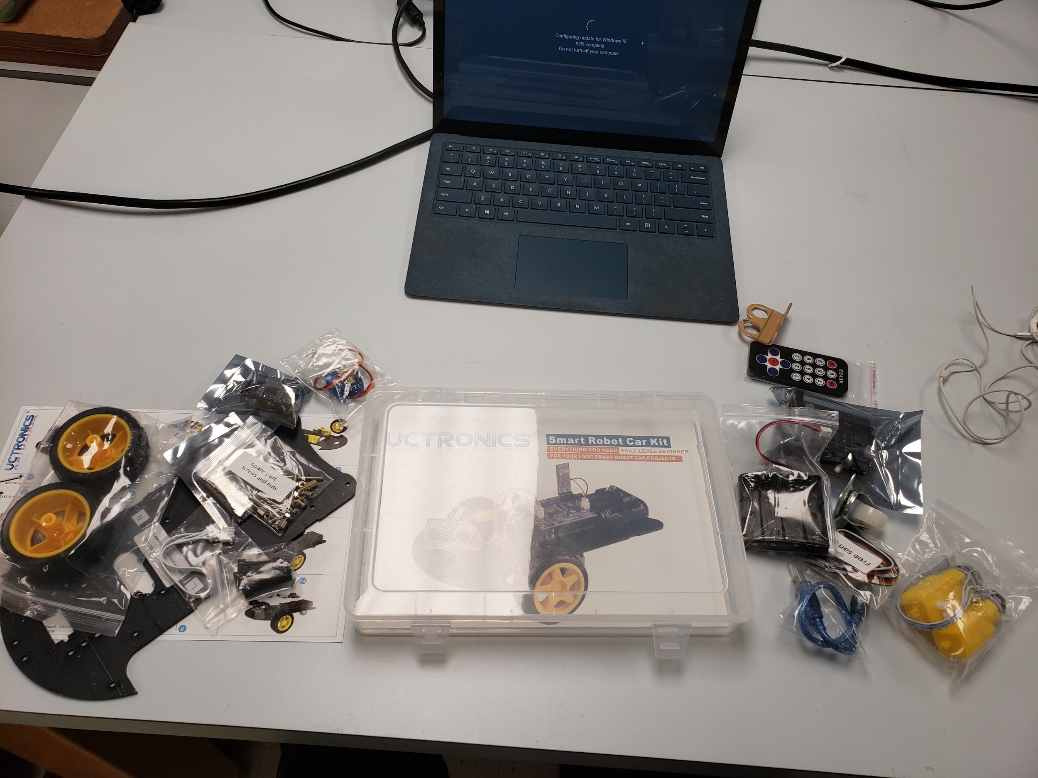

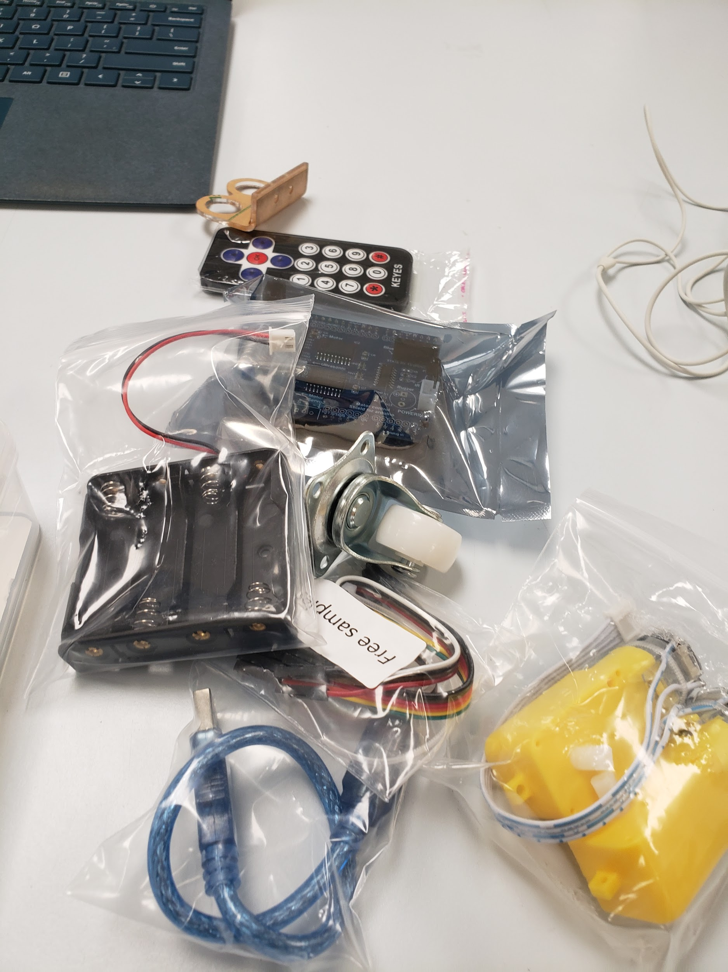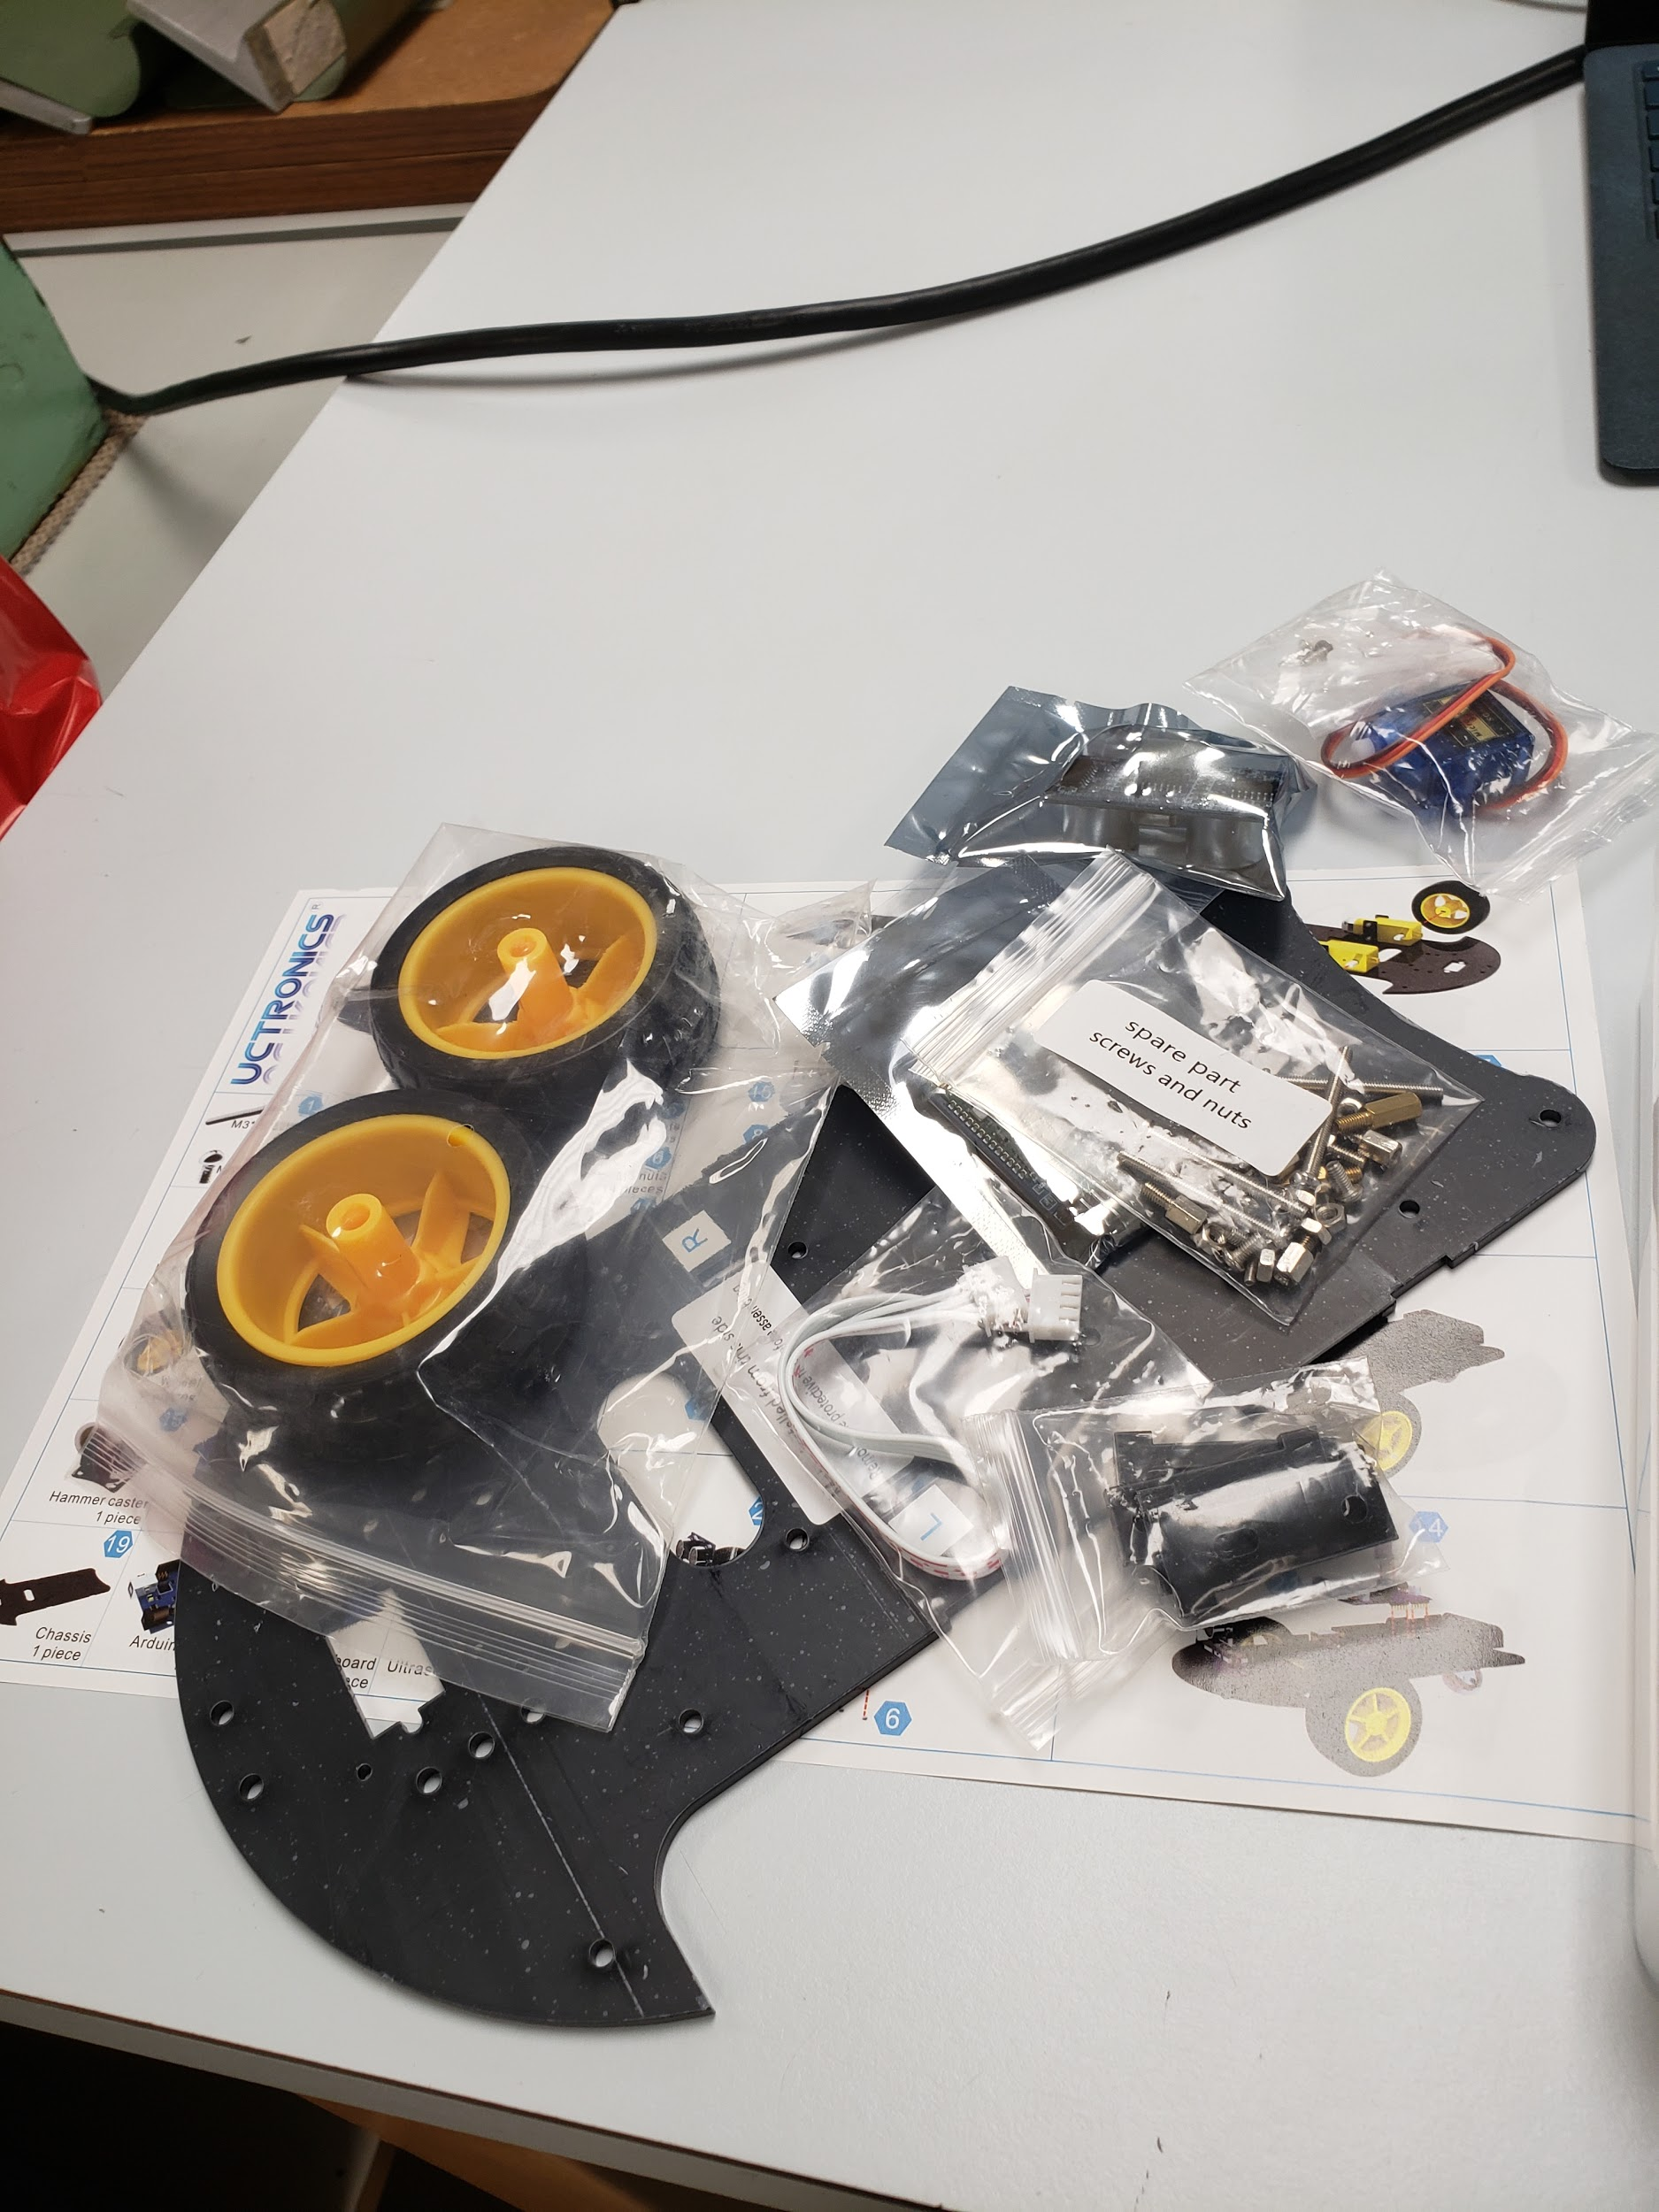

I couldn’t wait to get started so following the “manual” ( it’s in quotes because it's hardly one - primarily a set of pictures at various steps), I started building the buggy:

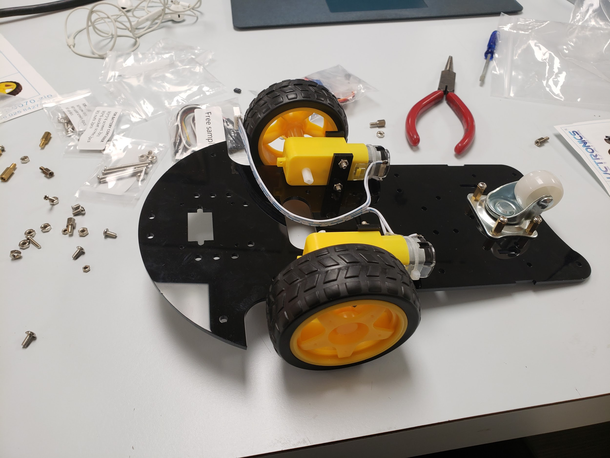

It is a little frustrating some of the design choices that were made by the manufacturer because the parts are hard to assemble in places - the bolts are too small and fit too tightly to be fitted by hand. I found some tools in the studio we work in, but I wish I had a magnetic screwdriver. It’s hard to hold the buggy, the screw, as well as try to tighten it at the same time! I steadily improved though and I could notice a difference at my skill within an hour. By the end of class I have completed about half the buggy. The wheels, motor, and battery case have been fitted. I still need to attach the “eye” (visual sensor) and the actual motherboard.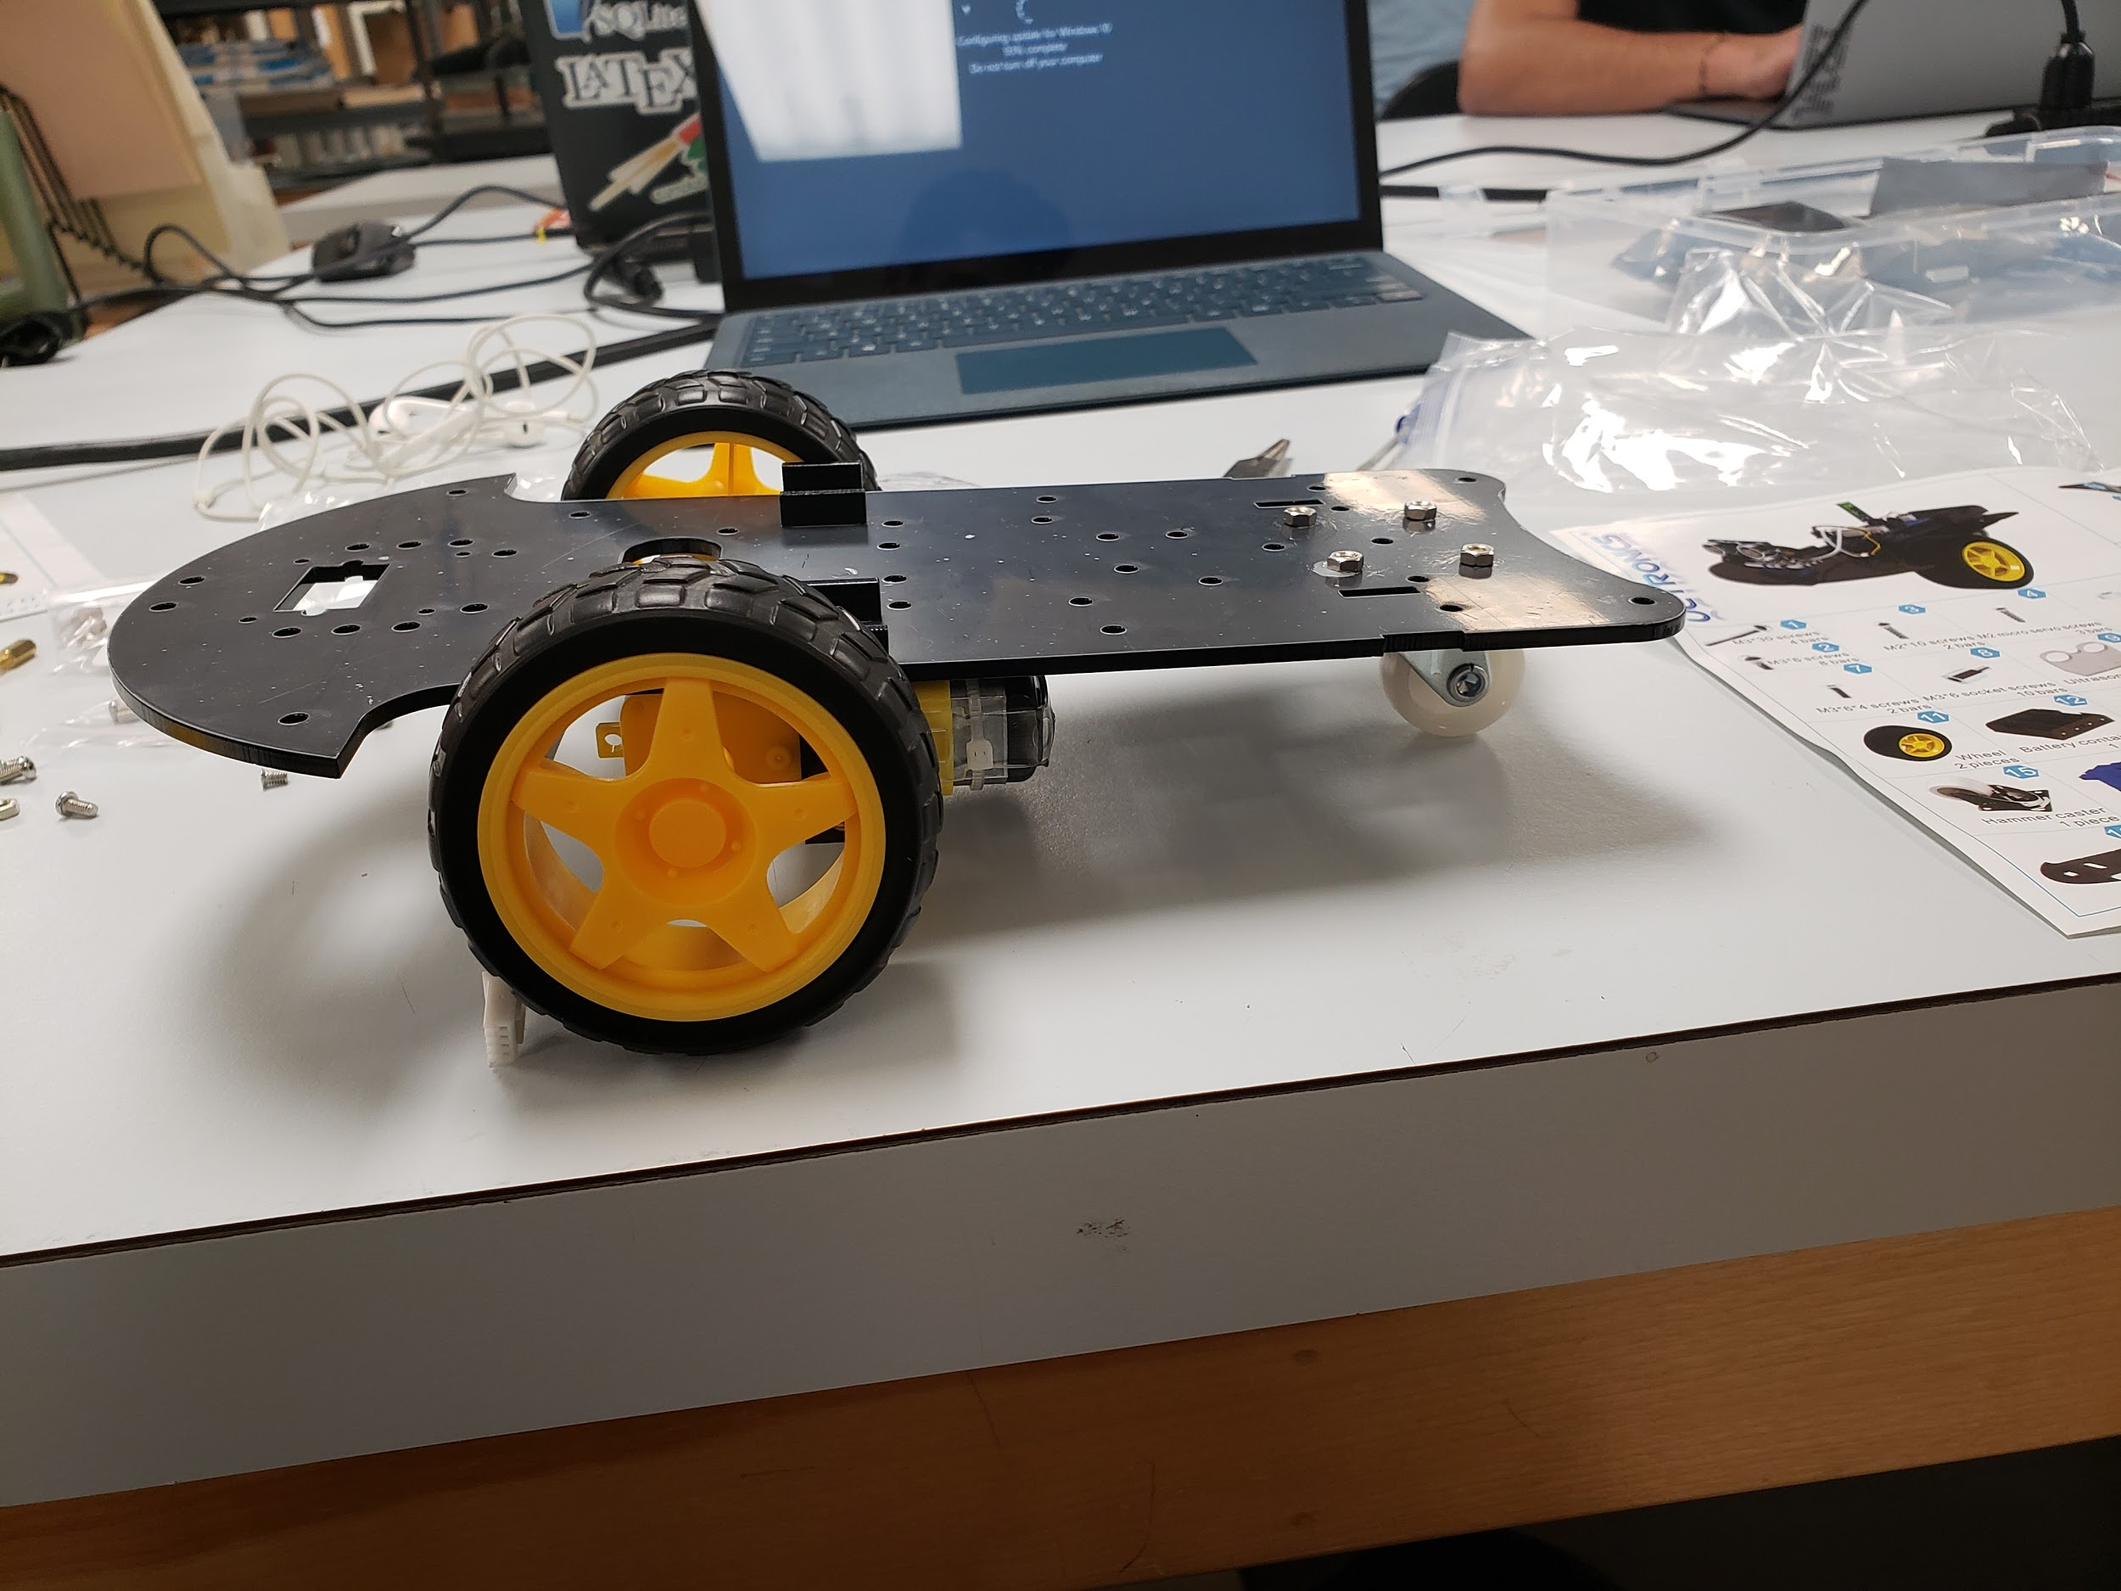

**October 10, 2018**

Today I spent the class time continuing to work on my robot buggy. I found a video demo online which I thought was useful - it provided a, quick, but useful animation of the buggy at different stages: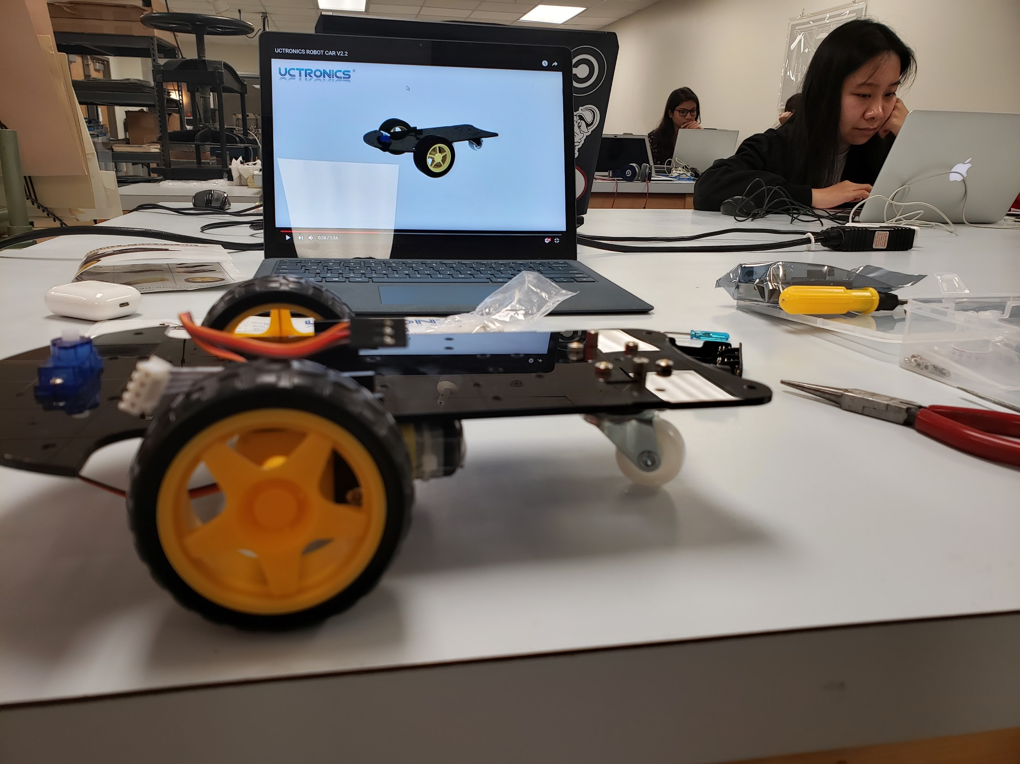

While watching this video, I realized that I had made the small rotating wheel wrong. I was supposed to put the pad above the hinges, not below. I consequently removed the wheel: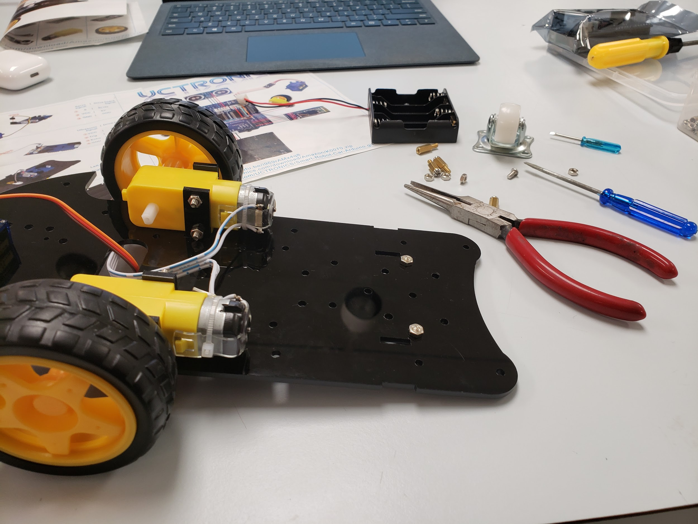

And attached it the right way. I notice that the car is much more stable now: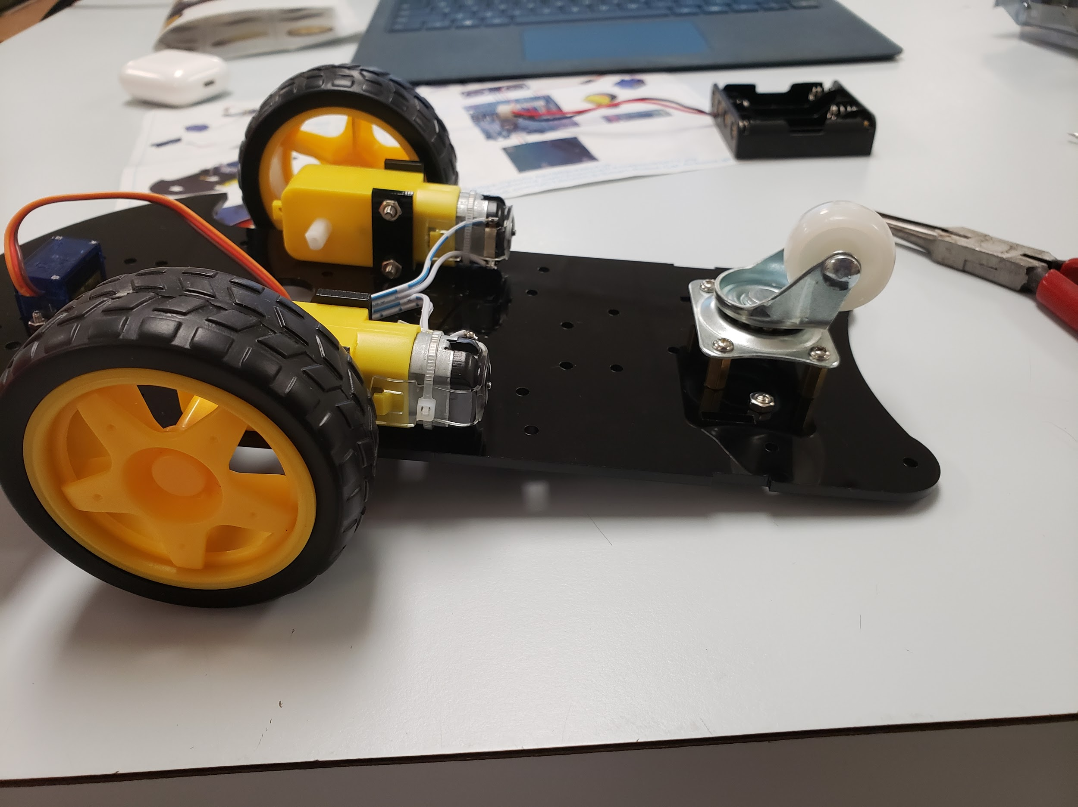

After fixing my mistake from the previous class, I proceeded to finish most of the hardware. I attached the “eyes” which are actually an ultrasonic sensor. I attached the Adruino motherboard and the battery case. I connected all the wires to the appropriate place and then realized I didn’t have batteries.

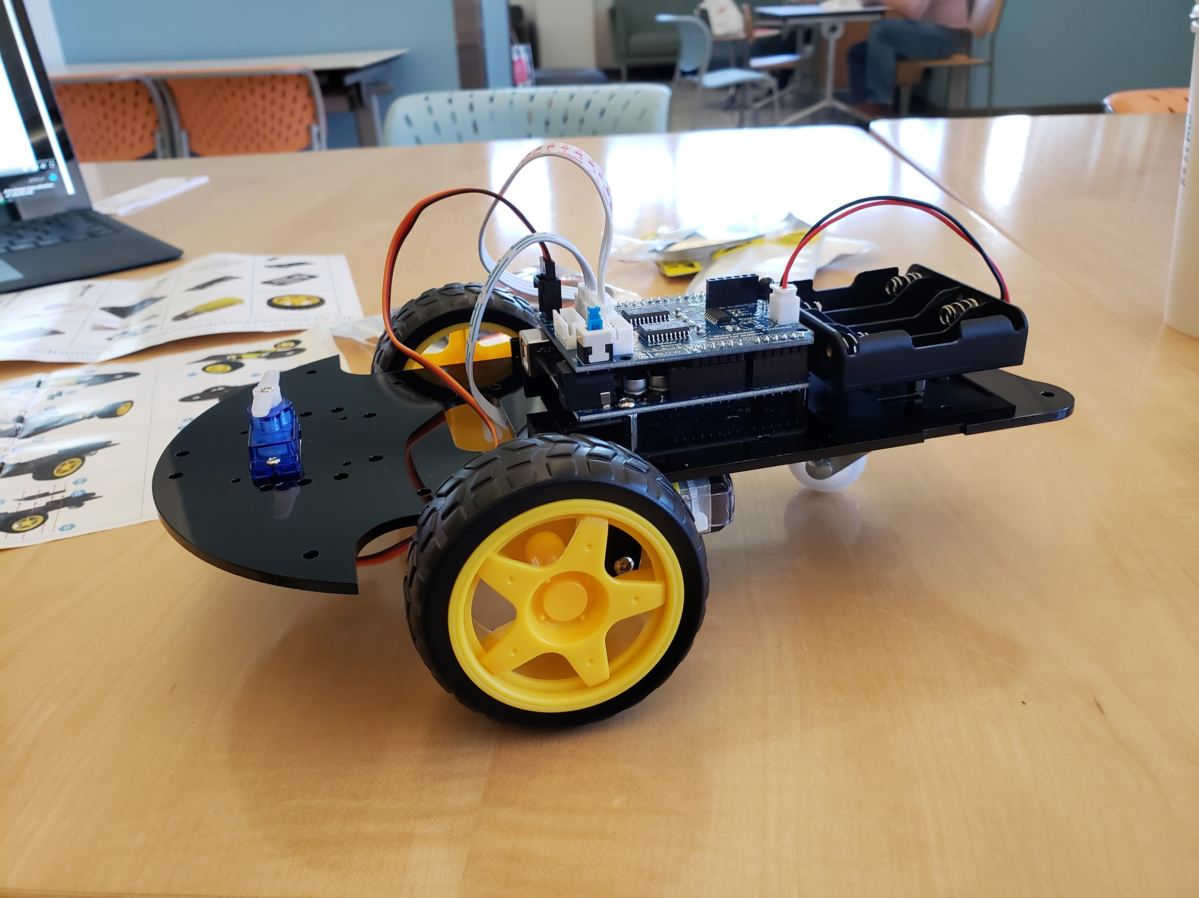

I ended up going to 7-Eleven and buying a bunch of batteries. I put them in the buggy and my robot car came to life for the first time! It was exciting to see it move around and show my peers what it could do. But as soon as it started to drive around, there was an obvious problem: it was moves backwards. And because the sensor was at the front and in charge of obstacle avoidance it just kept bumping into things ( to the point that I felt like it would break down from all the collisions). The “eyes were also very loose - the screws that came with it did not fit the base at all. After several attempts, I decided to try to superglue it:

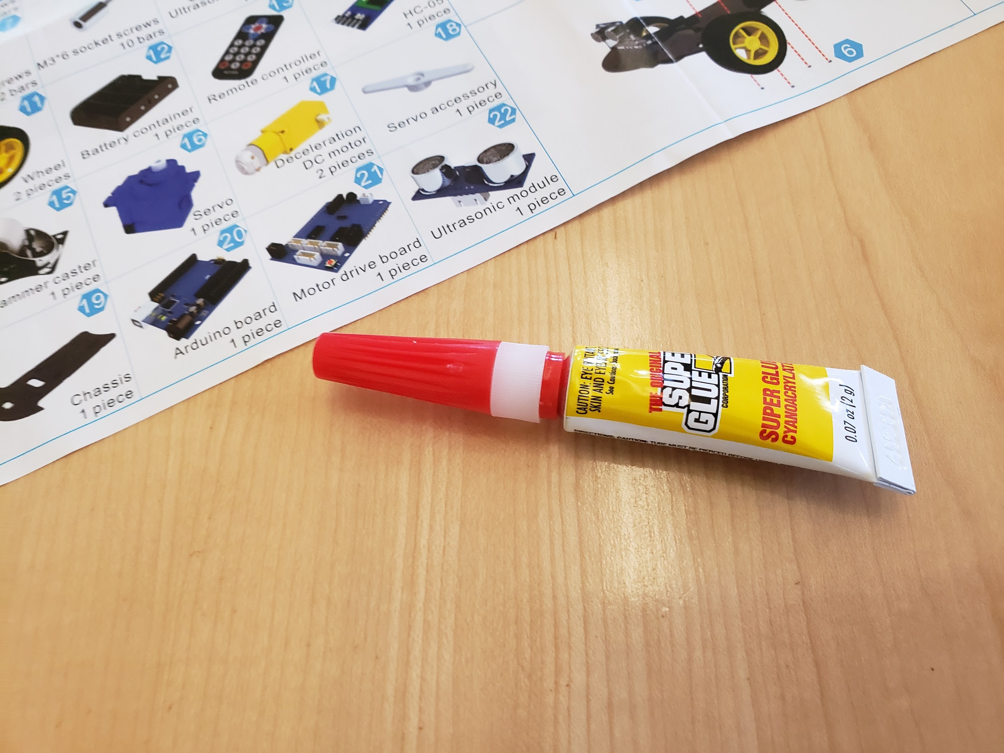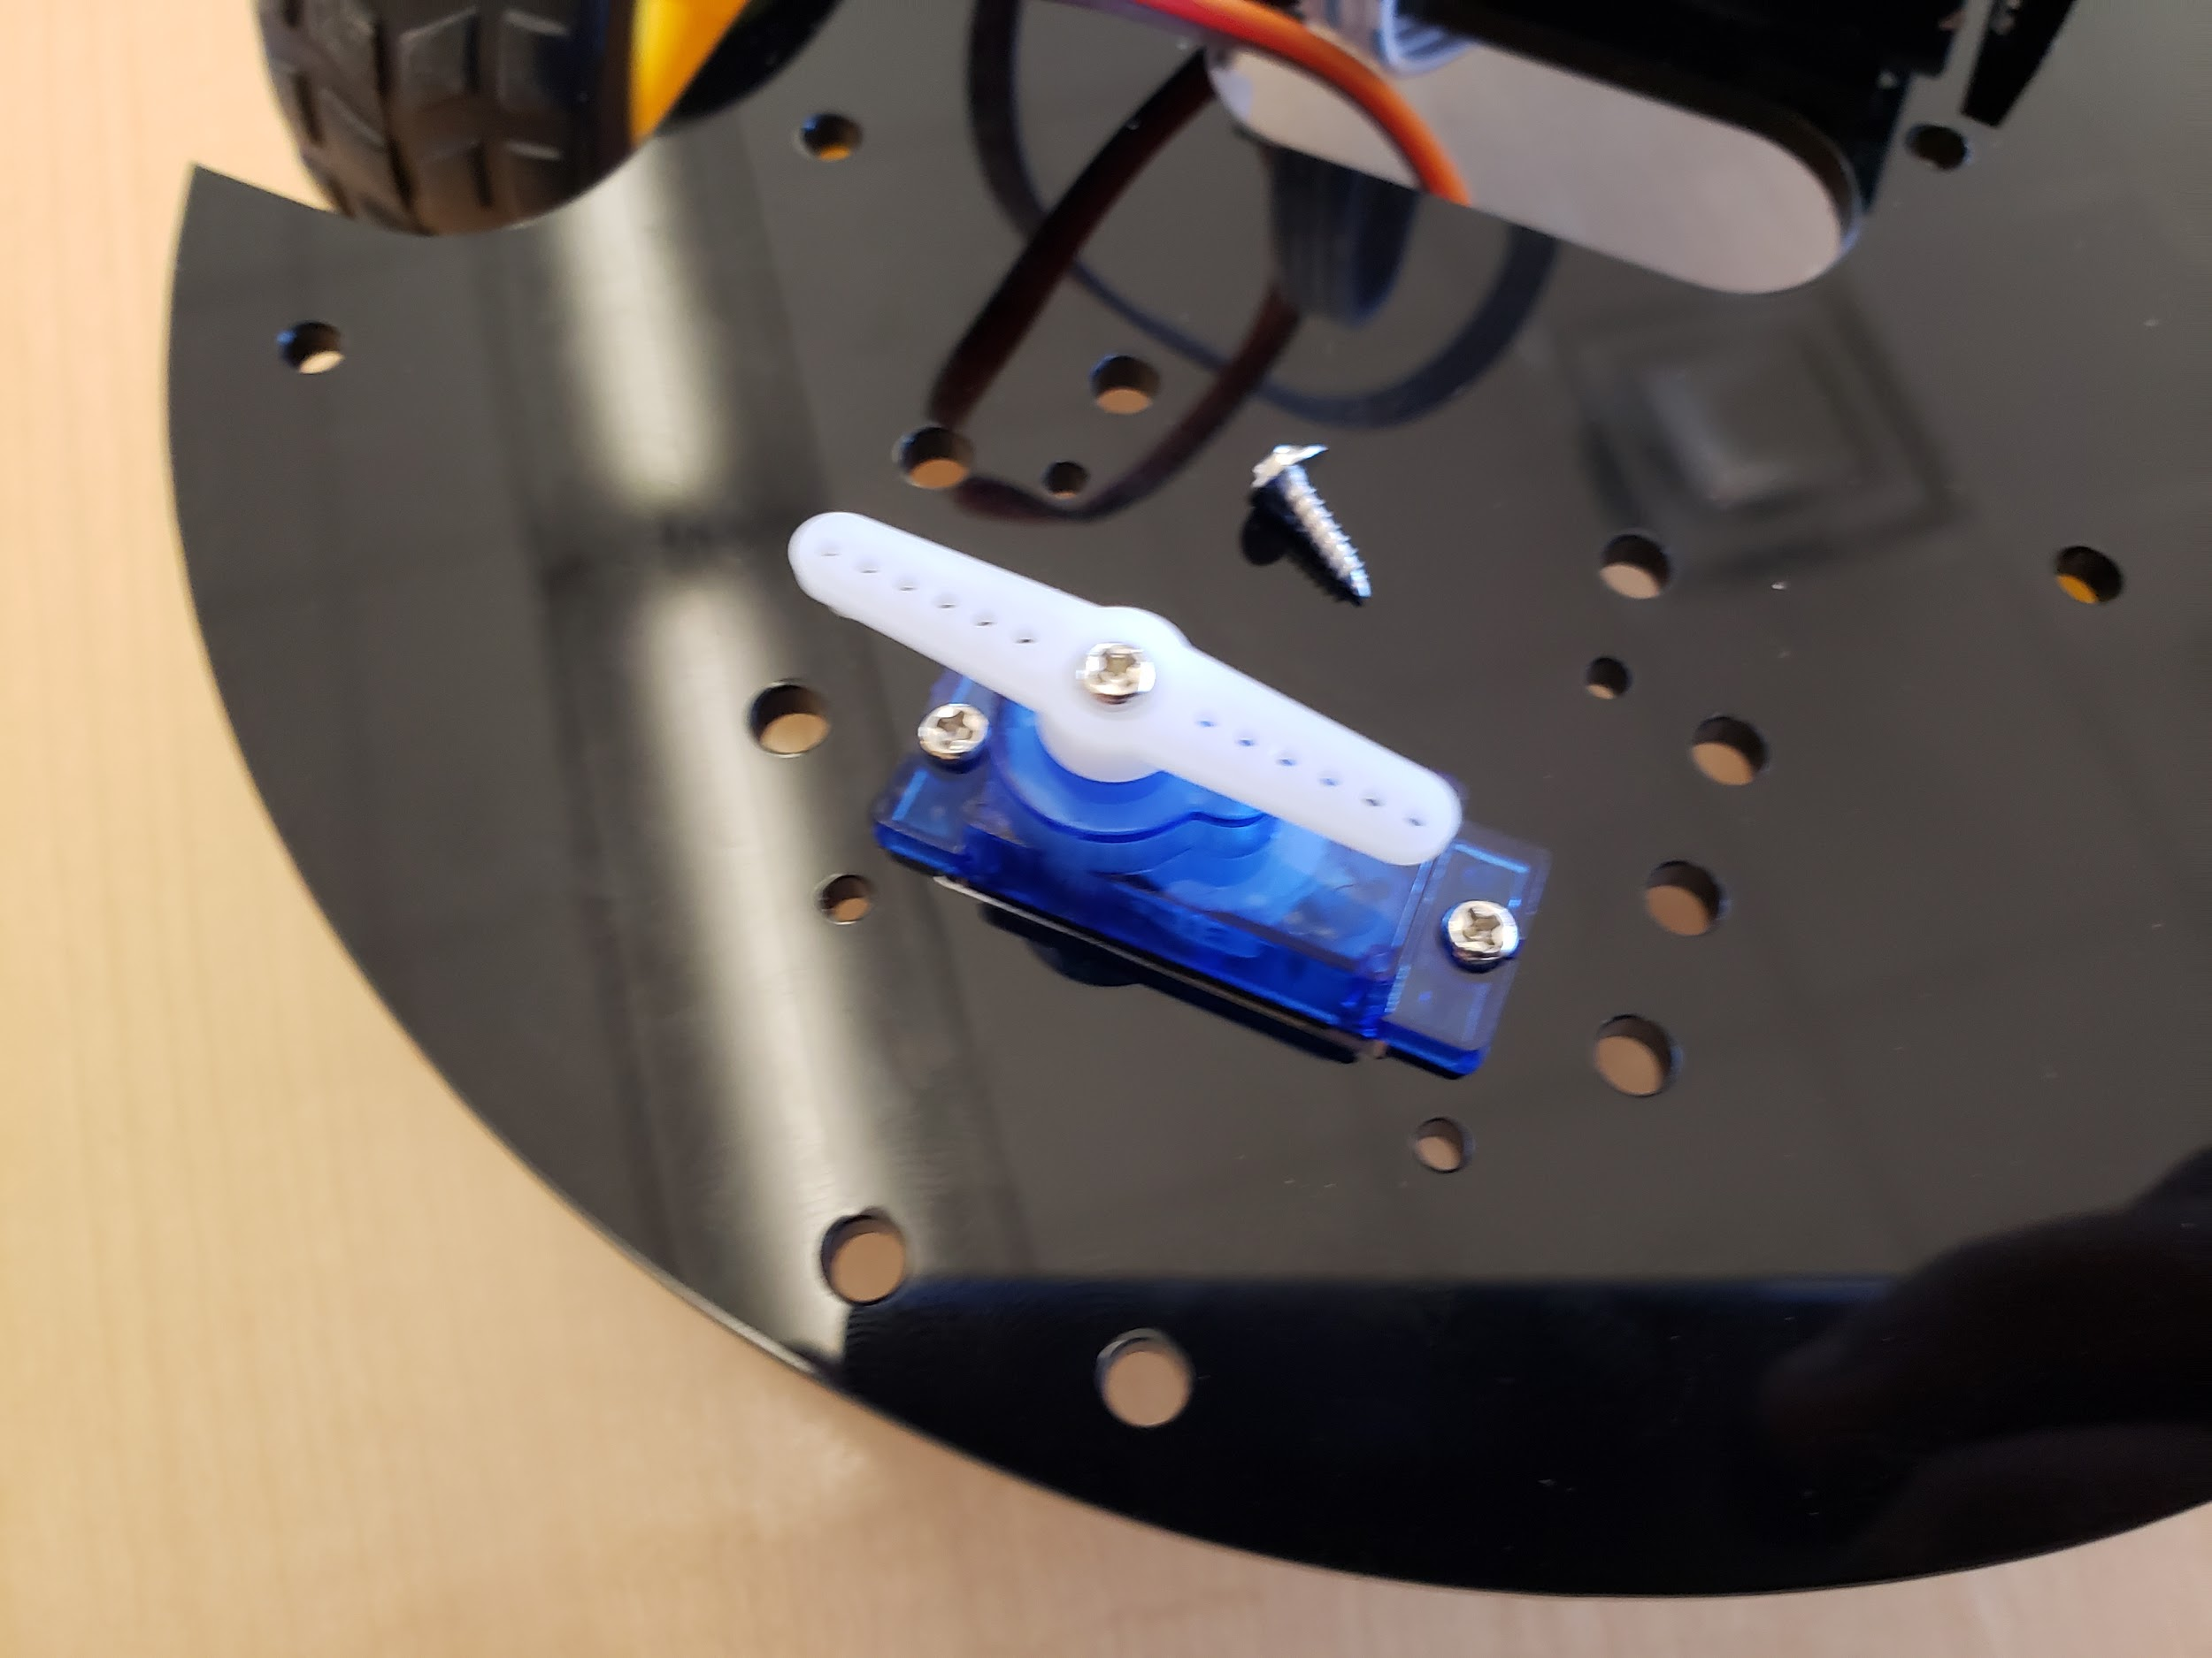

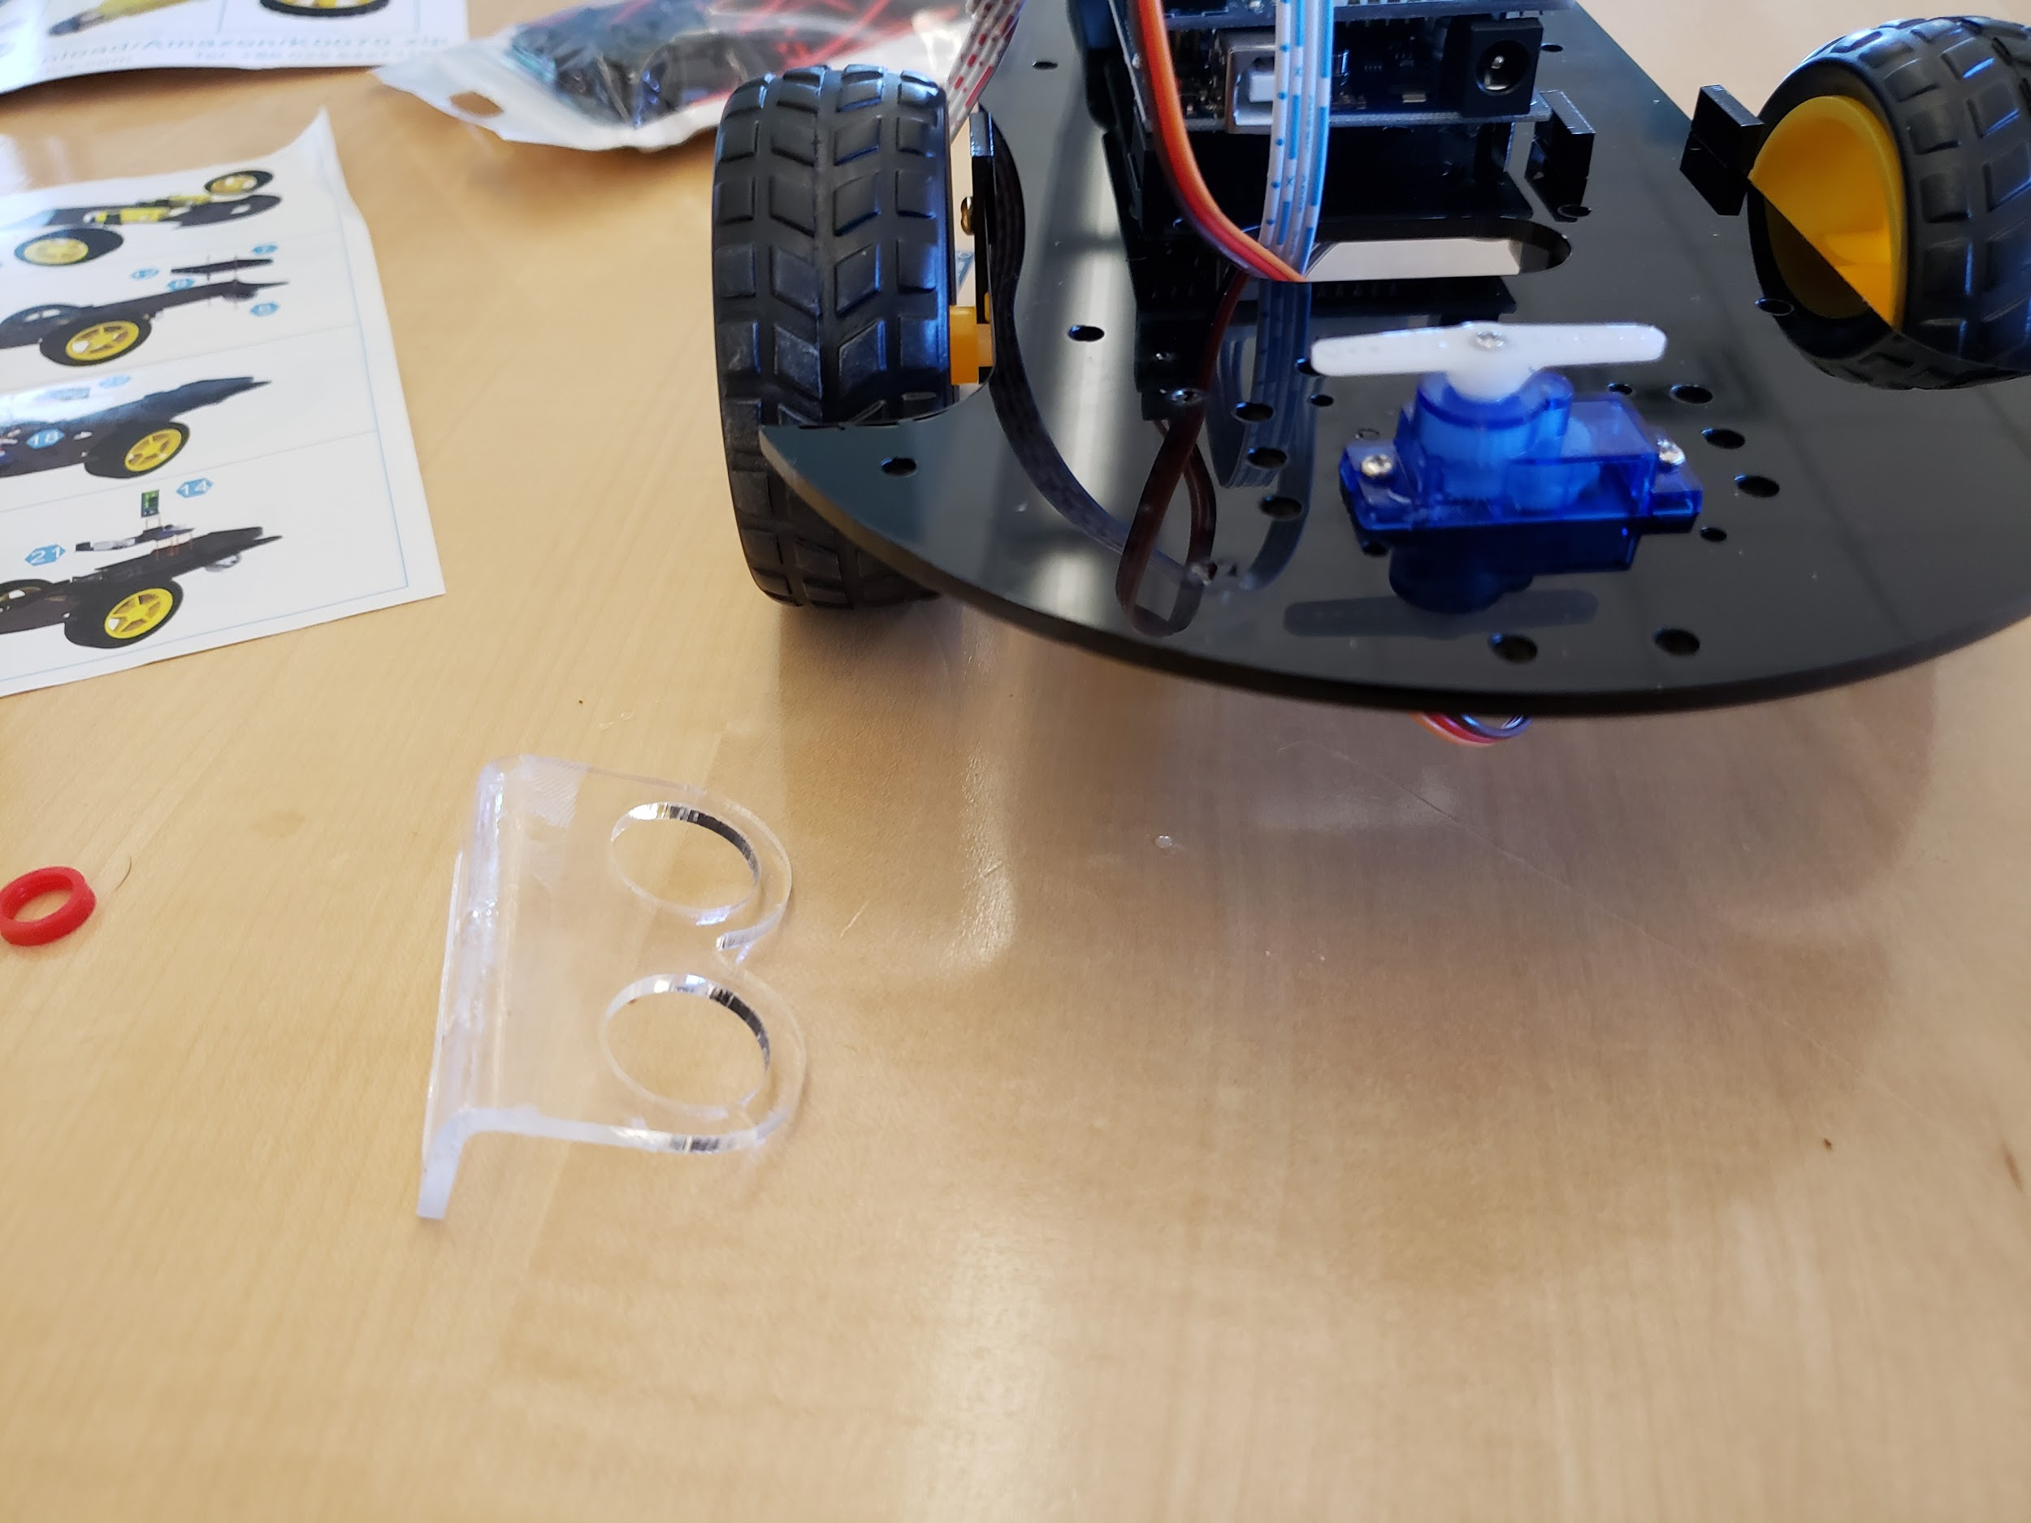

But all that happened was that I got very sticky hands. The sensor would not stay.

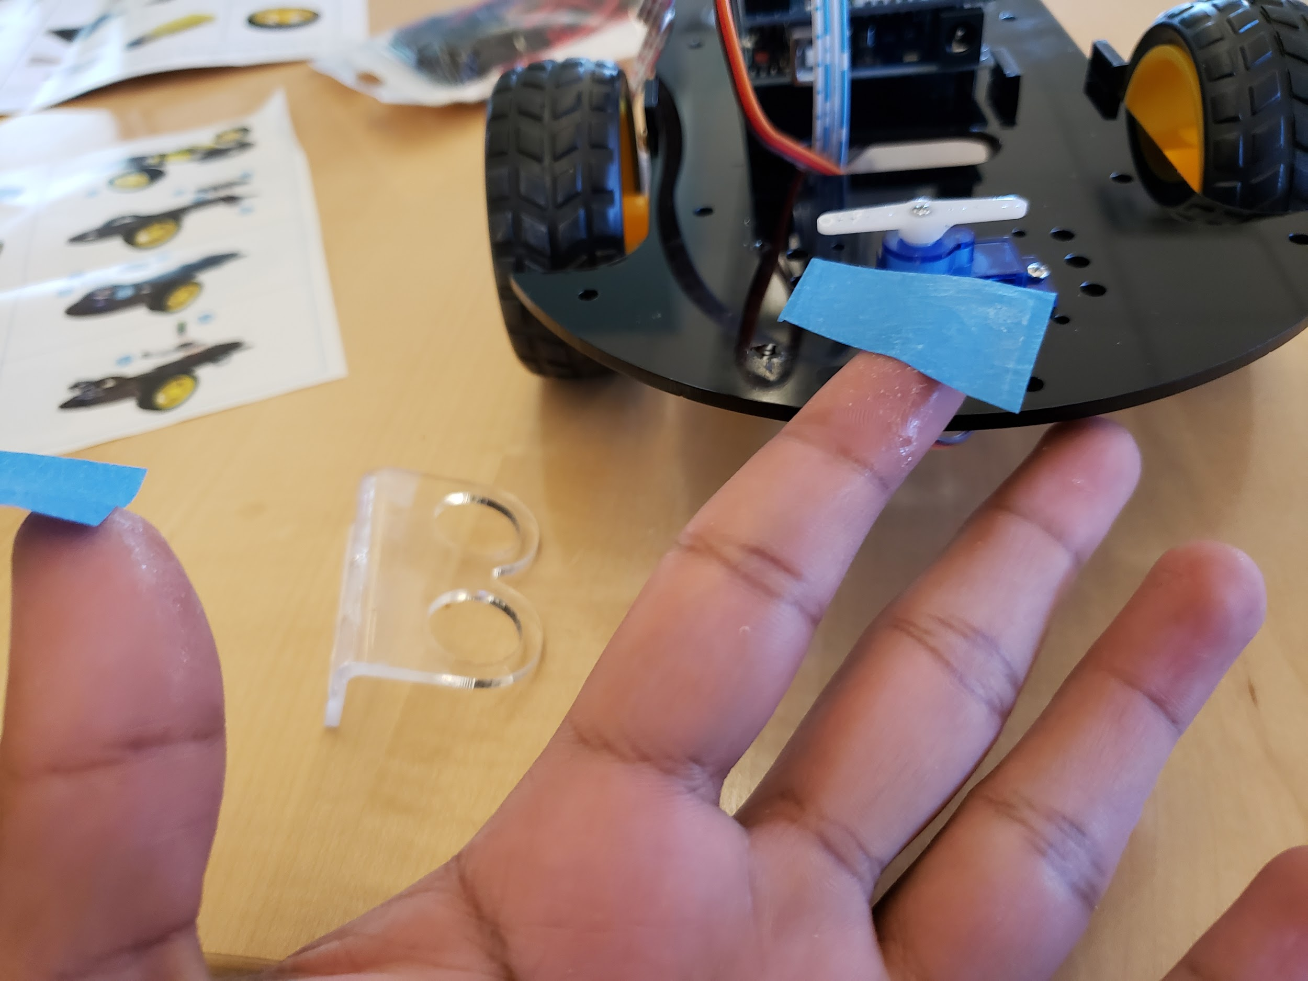

In the end, I decided to just duct tape it on!! That did the trick:

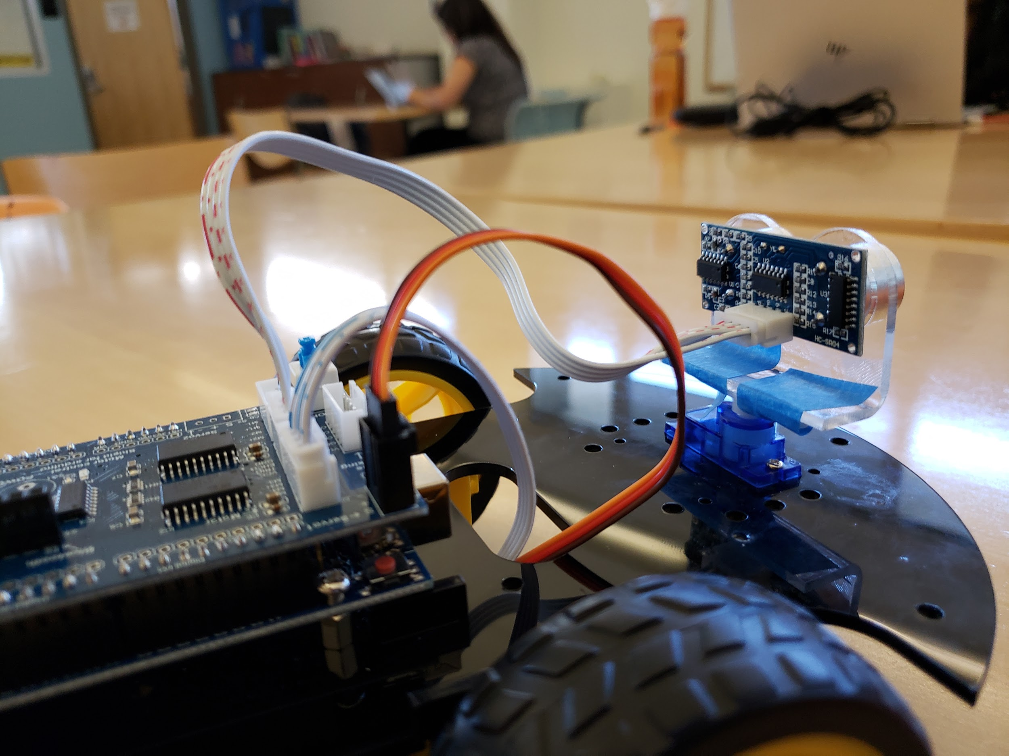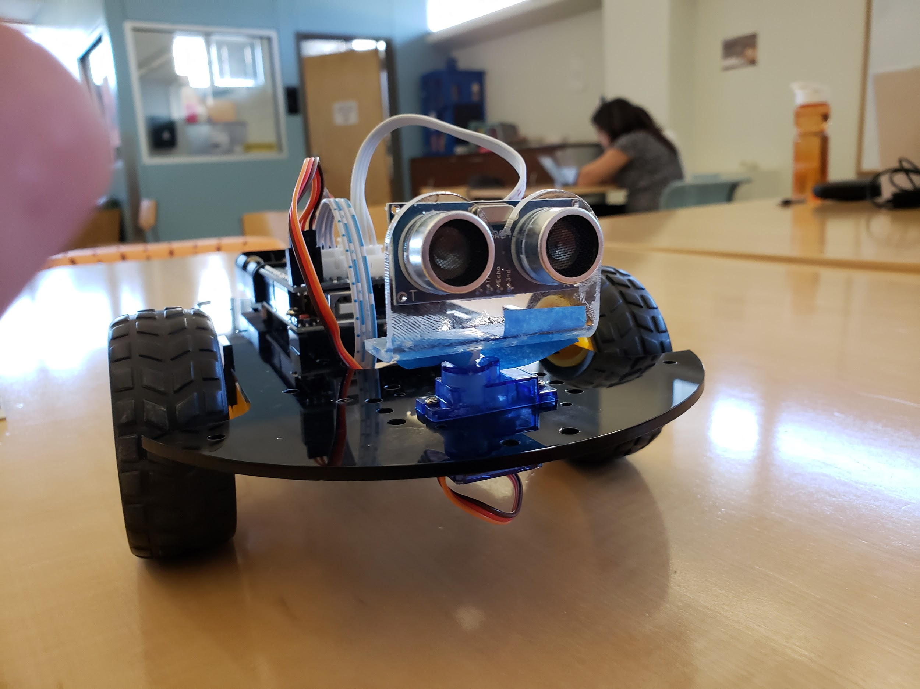

The buggy seems to be fully assembled but I still need to figure out why it’s running backward. I tried to switch around the motor but that did not solve the issue. I am now thinking it’s either a wiring or software thing. Next class I plan on playing around the with code that came with the robot and working out how to program it.

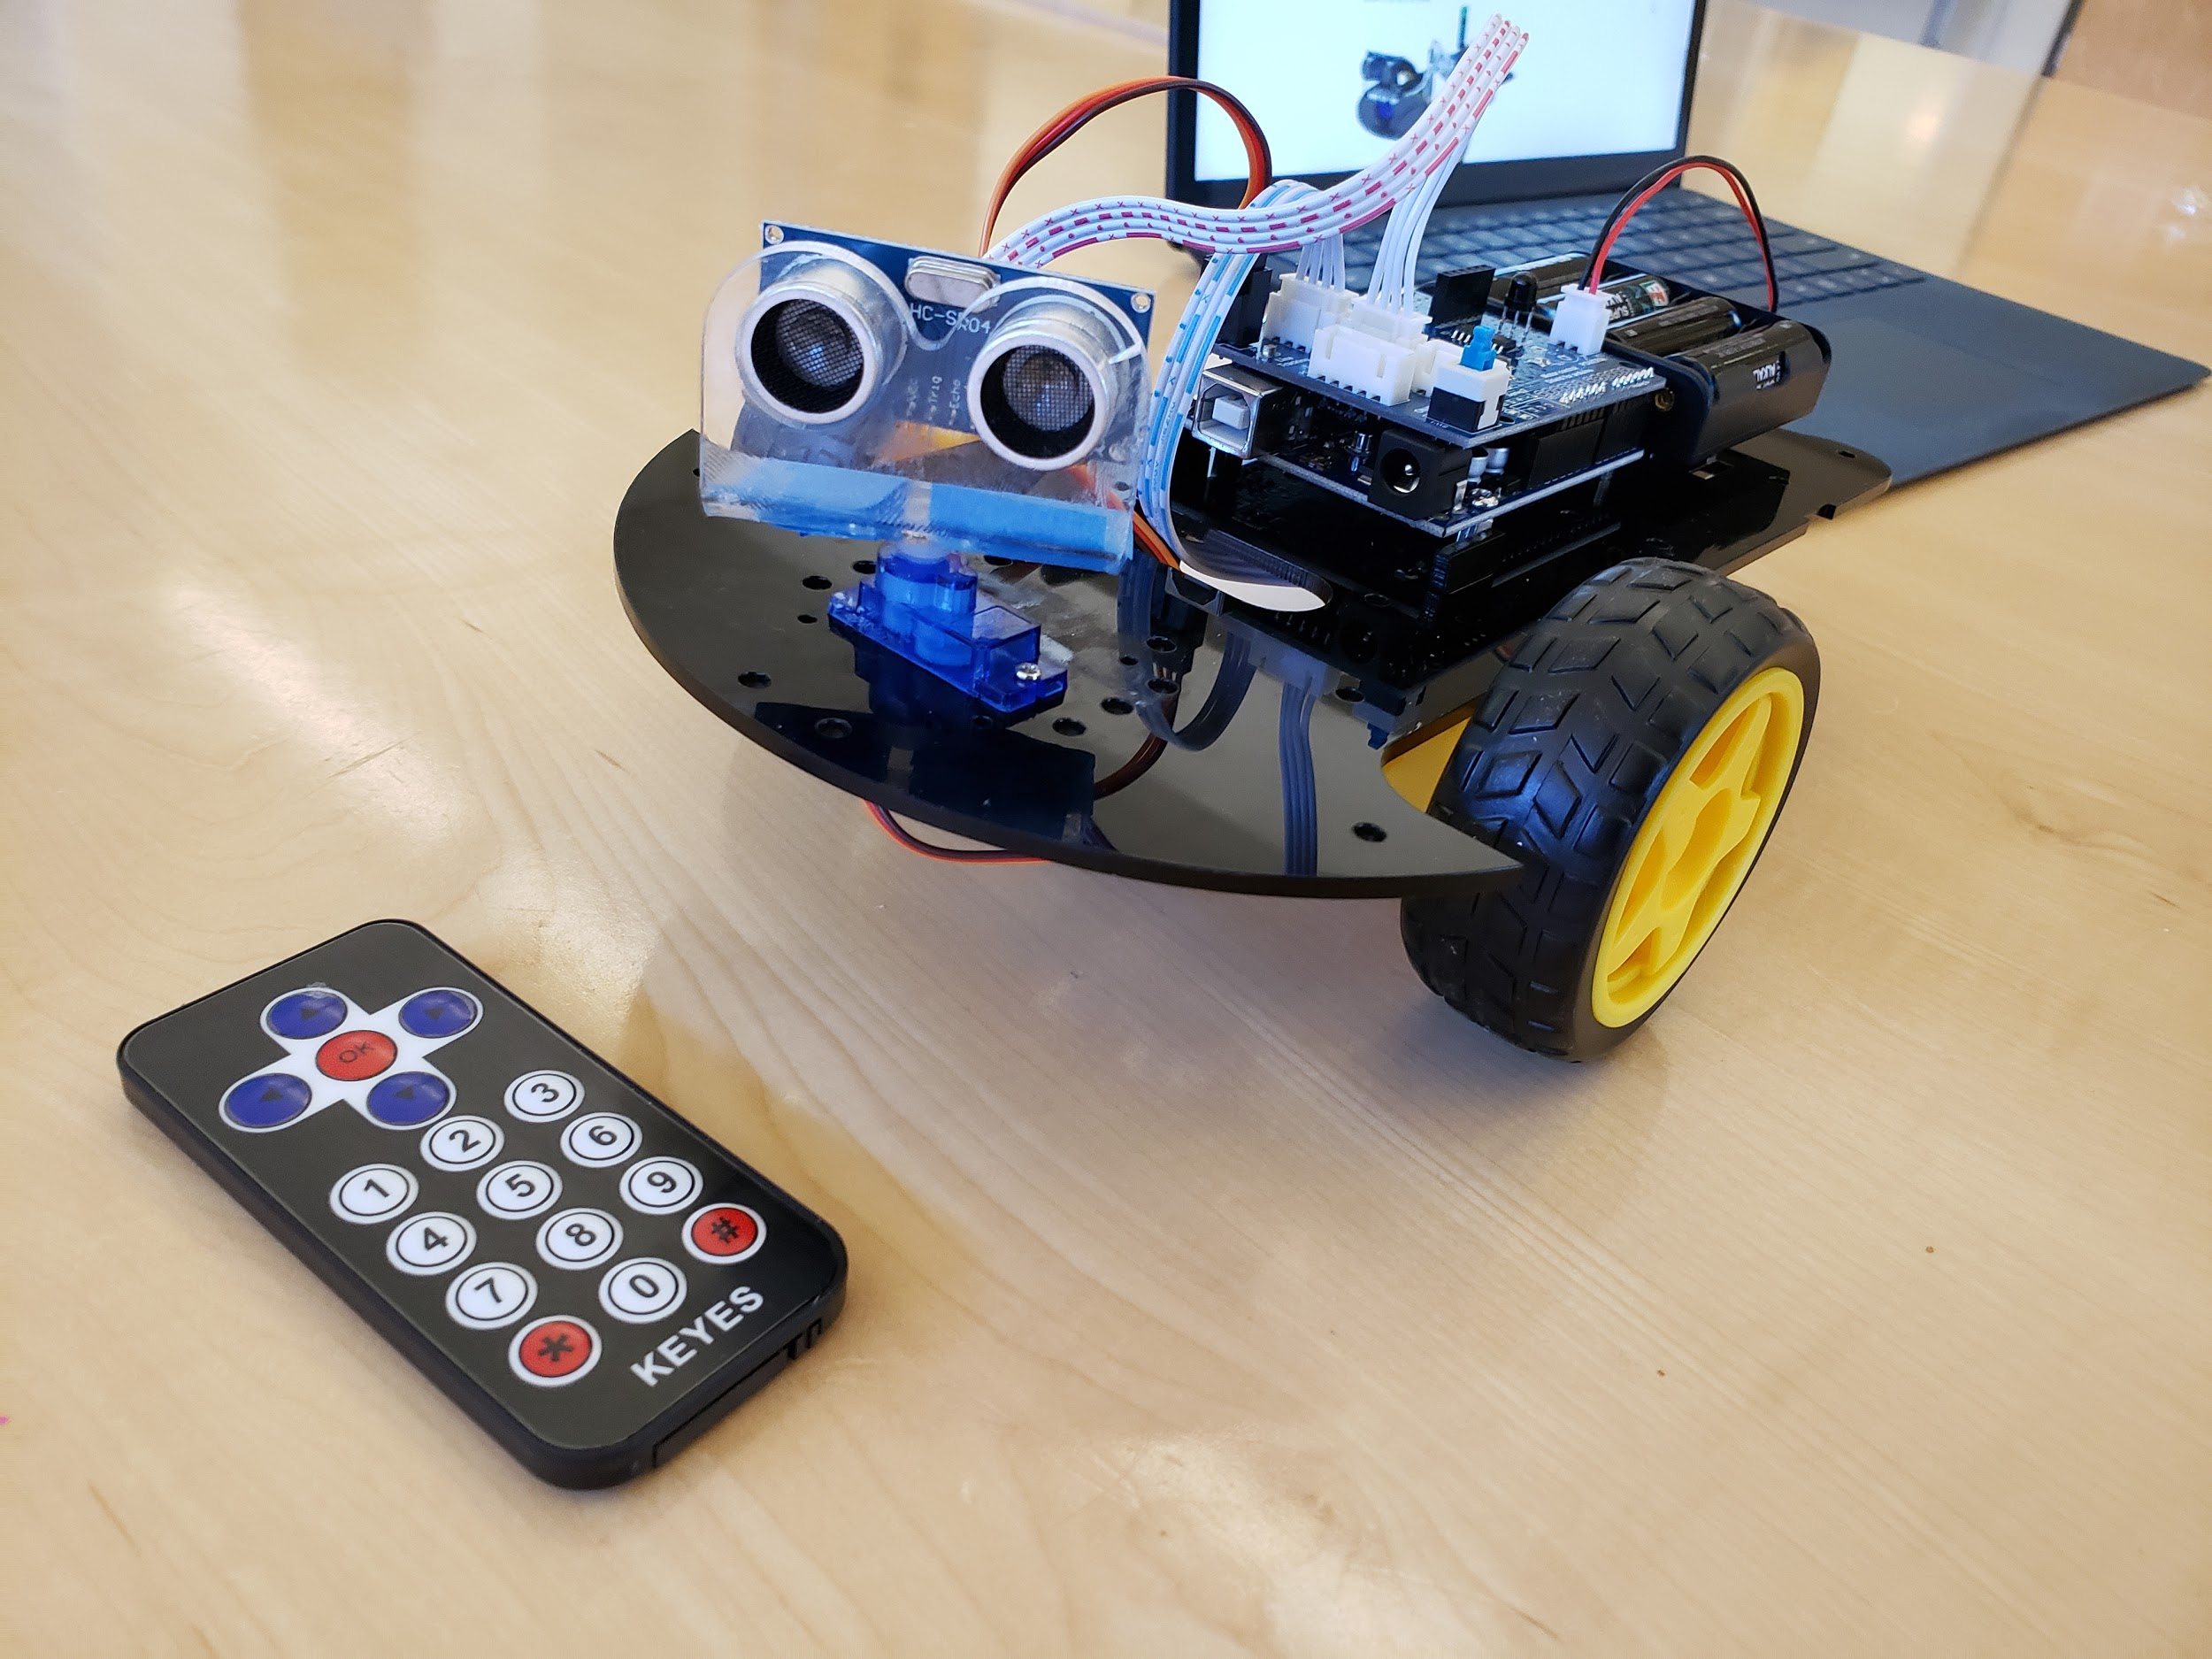

My experiences in class while working on the buggy was interesting - especially in light of the readings we did today. Kathryn Schulz’s Ted talk about Being Wrong explains how it's actually the realization of wrongness rather than being wrong that strikes an emotional response. This is certainly true for my mistakes - I did not even care until after I found out about the problem and how they affect the robot’s motion. John Green’s talk considers an analogy of a map with the idea of learning and charting out your own personal learnings. This makes sense to me too - while building this robot, it almost feels like I am discovering a new area of knowledge that was previously unknown in my map. It is also fascinating to find the connections/links with areas of my learning map that this can connect to. A central theme to both talks is to embrace the unknown and seek to see the optimistic side of failing and then learning - both individually and through a community. Next week, I plan on attending a meetup for microcontrollers like Adruino and Raspberry Pi. I am excited to see what this community of practice can teach me and how it will alter the way I feel about this project.

**October 15, 2018**

Today I went to a meet up called “Austin Arduino / Raspberry Pi / Microcontroller Build Days” :

<https://www.meetup.com/Austin-Web-Mobile-Electronic-Club-For-Beginners-Experts/events/zjtsrpyxnbtb/>

It was great to be able to be able to interact with others who are passionate about using microcontrollers to build new, innovate things. This meetup was very different to the one I went to for my first learning module. Whereas the first one was more of a sponsored presentation, this meeting felt more like a hangout - with people who shared similar interests around a topic. It was hosted at the Hackerspace in South Austin.

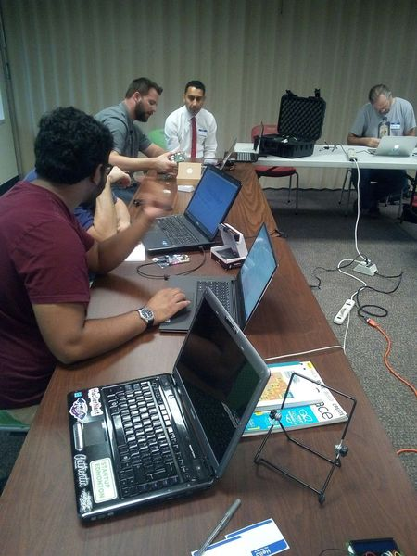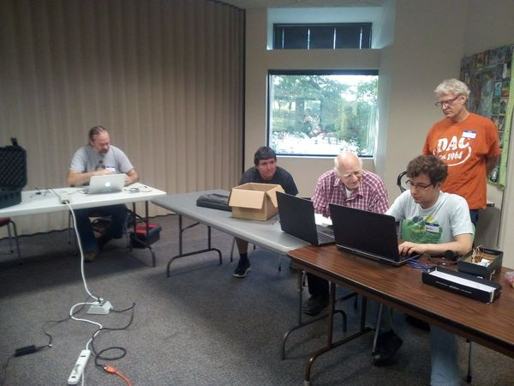

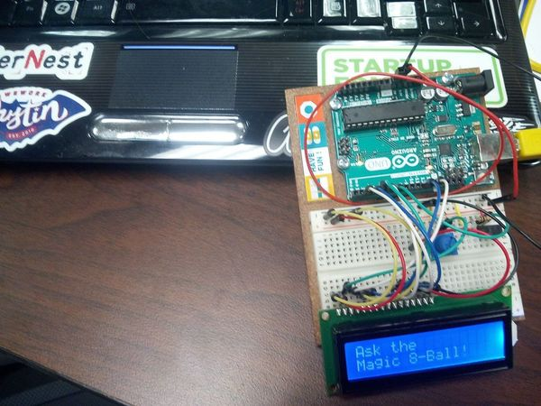

A considerable less crowded meetup gave me the opportunity to personally meet people on an one-to-one basis and learn more about their experience, projects, and future goals. Most people were doing this as a one, side project but were way more advanced as compared to me. Although I was simply following a kit, which was meant to be assembled in a specific way, everyone else was using these modular building blocks to create new things - kind of like 21st century inventors. It was really cool to get their views and it definitely expanded my views on the possibilities with these tools. I did not get a chance to stay too long as it started raining and I wanted to get home before it became any worse - but I had a great experience. I would definitely love to discuss and reflect more on this for our “Community of Practice” paper.

**October 17, 2018**

In today’s class I was finally able to “finish” my robot buggy. I put the word finish in quotations because I realize now that there are so many different ways I can end up taking this project and other expansions that can go with it.

After lots of struggles, I figured out why my buggy was going backwards - my motors were the wrong way around and even though I had previously tried to correct the orientation of the motors - I guess I had reversed both the motor and the sides - so it didn’t actually fix the problem. This time around - with a little more patience - I was able to test out the motor before fixing it in place and voila - the buggy was moving forward in no time! Now that the wheels were taking it forward and the ultrasonic sensor was facing the same way, it was really cool watching the buggy avoid obstacles on its own! It was exhilarating the robot come to life!!

But after admiring my robot car for a few minutes, a new problem was immediately obvious. For some reason, the calibration of the sensor seemed to be a little off - even when it was moving straight, the default position of the sensor pointed slightly right and therefore was unable to sense certain objects in front of it and still ended up banging into other objects. I took apart the sensor and while doing so realized that the piece itself was stuck - maybe I had screwed the top screw a little too hard? In any case, it just wouldn’t work. Thankfully though, Pedro had the same servo piece in his toolkit and was kind enough to let me borrow his. I removed the defected piece and replaced the un-faulty, working piece on to my robot buggy. It straight away solved the problem and in no time the robot buggy was dodging obstacles! It was really awesome showing my peers the car and watching my very first autonomous-driving “Tesla” move around. Even though I think the battery might be getting a little weak ? The power / speed seems to be dying a little bit. All in all it was a great day and I’m so glad I was able to finish the project and looking back, I value all the struggles I had to overcome because it makes the end product that much more precious. This is a picture of the final outcome:

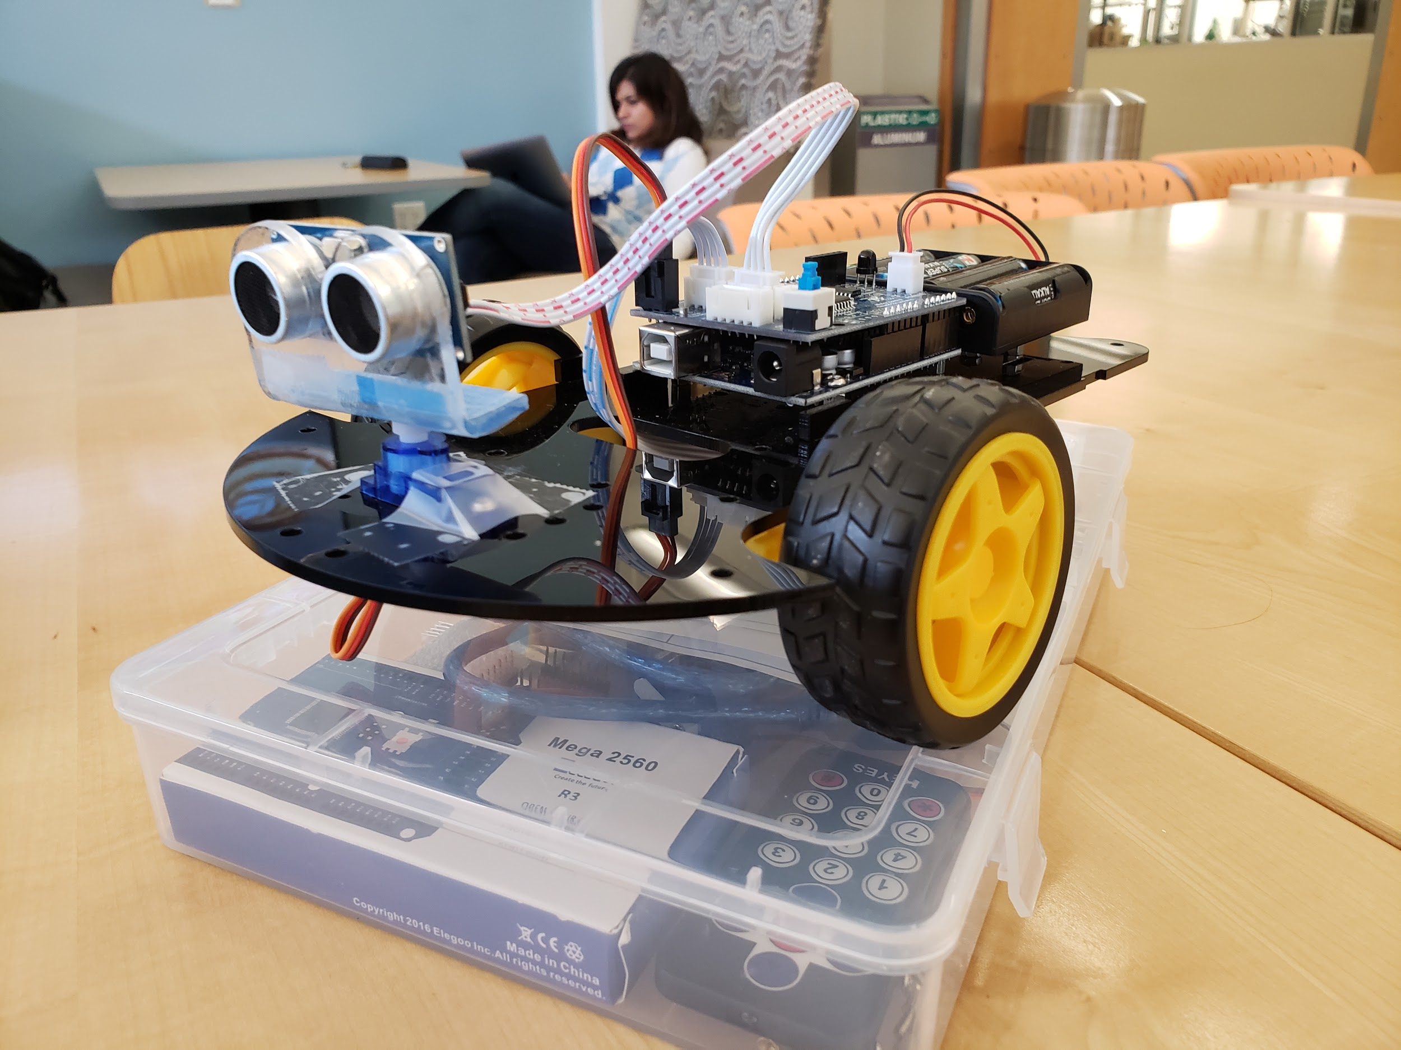

Next class, I might decide on designing an obstacle course for the robot car to test it’s capabilities to find out where it can and cannot work. It was really interesting see the car navigate successfully in a maze of chair legs but then get stuck onto a table ledge. The sensor’s vision isn’t panoramic enough for its wide body and so it ends up hitting items that it cannot detect. It’d be cool to figure out other such strengths/flaws on this design. I might also try to look into the software / code to see if there are any tweaks I can program into it - such as following a line or making an 8 shape pattern. I’ll be brainstorming other ideas until next class!

**October 24, 2018**

Today is the last day of class for the second learning module. I’m glad that I’ve finished creating my project. This gives me a chance to review my creation and reflect: I think my second learning module went better than the first module. I think it’s mainly because I was more clear about the timeline and therefore I was careful at setting achievable goals. It was definitely easier working with a pre-made kit that had all the parts I would need and an instruction manual to follow. In hindsight, I’m happy I did that - if I had not done that I would have probably spent like 2 out of the 4 classes just figuring out what pieces/sensors/boards I would need and are compatible with each other. That would have left me with not enough time to play around with building it as I would have liked.

Building this robot buggy has helped me get a much more hands on overview of building robots, using Adruino, and wiring sensors. I think I knew most of it at a conceptual level - but actually using the parts and putting it together really helped solidify how the pieces work as a whole. On the other hand, I don’t think I got to work with programming the robot as much as I would have liked. This was probably also a consequence of using a ready-to-go kit. It came with some basic functionality built in and therefore did not require me to get into that much. In the future, I would love to dig deeper into how to program the robot. Though I have found through research that the Adruino motherboard requires learning its own language whereas the Raspberry Pi supports Python (which I already know), so it might make sense doing that. It doesn’t seem to be too much trouble switching boards for different projects as most of the sensors and wiring works with both! As I experienced in my second learning module, it might seem that way until you do it so I suppose I’ll really find out when I get a chance to test it out!

**October 31, 201****8**

Today is the start of the third learning module. After completing the first and second learning module, I thought it’d be helpful to my learning process if I started by reflecting on some things I want to take into the third module. Having done the physical module in my second module, it sets me up nicely to be able to compare and contrast the difference between learning approaches for physical projects as opposed to technology ones. When doing technology related projects it is much easier to redo work. Whereas in a physical setup you are literally required to redo everything over and over until you have got it right. In some ways, this is better for learning as you are forced to memorize through repetition but on the other hand, coding intrinsically doesn’t need that and it's difficult to think of a project in which you would be forbidden to replicate code that might be useful. I think in my second learning project, it worked better to set a small achievable goal (especially when you think about the fact that you only have 4 weeks for each module in this class). I definitely want to continue that theme in my third module. It’s also interesting to think about the differences in the ‘chunkiness’ of a physical and technology projects. When it’s something physical, you usually have a very logical stopping point - like when you’re done building it! But with software, it’s quite easy to learn tangents around the topic of choice. This can be both a positive possibilities for your learning but also a challenge. Obviously, it enables you to learn more modularly but you can get stuck through a ‘paralysis of options’. This is something that I am seeing arise more and more with the advent of the internet. With so many learning resources, specifically for learning coding, it can be difficult to focus on any one particular topic. For this reason, I spent a good chunk of time in class today really honing in on what Ii want to do and achieve for my third learning module:

**Learning Module 3: Kubernetes**

Goals:

* Learn the overview of the tool and its capabilities
* Implement a small, but functioning container orchestration where I can run an application through micro-services

Materials:

<https://kubernetes.io/docs/tutorials/kubernetes-basics/> - the offical page has some tutorials

<https://app.pluralsight.com/library/courses/getting-started-kubernetes/table-of-contents> - a course about the overview of the tool

Activity:

1. Complete watching the overview videos to gain a basic understanding of the strengths and weaknesses of the tool and why it might be useful to implement such a system
2. Following tutorials, setup a home container orchestration platform
3. Deploy a dockerized app to a cluster and play around with Kubernetes functionality

This time around, as opposed to my first learning module, I have outlines a direct set of steps I want to follow because I felt like my activities section was too broad. I would rather err on the side of caution and start with small but achievable targets and add to them, time permitting. While working on this activities section, I realized that there is also another interesting difference between physical and technology learning projects. I have a much better understanding of what a physical projects entails as opposed to a software based one. I think it’s maybe because I have a better “mental map” built for what is required for on physical projects. With software, you don’t know which rabbit hole you might end up having to go down and that can often lead into a massive delay in your schedule or deviation from your original plan. I will keep a tab on this insight as I progress on my learning module this time around.

**N****ovember 7, 2018**